**Software Requirement Document**

**ORTA: Optional Retirement Transfer Application**

Version: 0.2

Date: 2/18/2014

Author: Mehvish Afzal & Roopa Reddy

**Version Control**

|  |  |  |  |
| --- | --- | --- | --- |
| **Version** | **Date** | **Summary of Changes** | **Author** |
| 0.1 | 2/1/2014 |  | Roopa Reddy |
| 0.2 | 2/18/2014 | New Application Design | Mehvish Afzal |
|  |  |  |  |
|  |  |  |  |

**Distribution Control**

|  |  |  |  |
| --- | --- | --- | --- |
| **Version** | **Date** | **Title** | **Name** |
| 0.2 | 2/18/2014 | Lead Customer Representative |  |
|  |  | Sponsor |  |
|  |  | Project Manager |  |
|  |  | Project Management Office |  |

**Approvals**

|  |  |  |  |  |
| --- | --- | --- | --- | --- |
| **Version** | **Date** | **Title** | **Name** | **Approval On File** |
| 0.2 | 2/18/2014 | Lead Customer Representative |  |  |
|  |  | Sponsor |  |  |
|  |  | Project Manager |  |  |
|  |  | Project Management Office |  |  |

1. **Table of Contents**

1 Introduction 8

1.1 Background 8

1.2 Scope 8

1.3 Objective 9

1.4 Intended Audience 9

1.5 Assumptions 9

2 Process flow 10

3 Requirements 12

3.1 Conversion of ORP Data to SQL server 12

3.2 Data input of participants from Comma delimited file to ORTA DB 12

3.2.1 Functional Requirements 12

3.2.1 Screen Mock Up: 12

3.2.2 Field Related Information for Participants Payroll: 12

3.2.3 Field Related Information for Participants Information: 12

3.2.4 Validation Messages: 14

3.2.5 Screen Control / Navigation Rules 14

3.2.6 Other Details 14

3.3 Standard Template 15

3.3.1 Functional Requirements 15

3.3.2 Standard ORTA Template for User (Page Mockup) 15

3.3.3 Standard ORTA Template for Administrator (Page Mockup) 16

3.3.4 Field Related Information for `Participants Search’ 16

3.3.5 Validation Messages 17

3.3.6 Screen Flow 18

3.4 Participant Search 18

3.4.1 Functional Requirements 18

3.4.2 Screen Mock Up: 19

3.4.3 Field Related Information for `Search Criteria’ 19

3.4.4 Validation Messages 22

3.4.5 Screen Flow 22

3.5 Participants Details 23

3.5.1 Functional Requirements 23

3.5.2 Screen Mock Up: 23

3.5.3 Field Related Information for `Participants basic information’ 24

3.5.4 Validation Messages 28

3.5.5 Screen Flow 28

3.5.6 Notice of Eligibility 28

3.5.6.1. Functional Requirements 28

3.5.7 Reminder Letter 28

3.5.8 Forfeiture Letter 29

3.5.9 Field Related Information for `Notice of Eligibility’ 29

3.5.10 Validation Messages 30

3.5.11 Screen Flow 30

3.5.12 Notice of Interest received: 31

3.5.12.1. Functional Requirements 31

3.5.13 Field Related Information for `Notice of Interest’ 31

3.5.14 Validation Messages 32

3.5.15 Screen Flow 32

3.5.16 Information Package 33

3.5.16.1. Functional Requirements: 33

3.5.17 Field Related Information for `Information Package’ 34

3.5.18 Participants Election form: 36

3.5.18.1. Functional Requirements: 36

3.5.19 Field Related Information for `Participants Election form’ 36

3.5.20 Validation Messages 37

3.5.21 Screen Flow 37

3.5.22 MSERS Enrollment 38

3.5.22.1. Functional Requirements 38

3.5.23 Field Related Information: 38

3.5.24 DHE Confirmation letter 39

3.5.24.1. Functional Requirements: 39

3.5.25 Field Related Information: 39

3.5.26 Validation Messages: 41

3.5.27 Screen Flow 41

3.6 Participants status: 42

3.6.1 Functional Requirements 42

3.6.2 Screen Mock Up: 42

3.6.3 Field Related Information for `Participants Status’ 42

3.6.4 Field Related Information for `Provider information’ 44

3.6.5 Field Related Information for `Providers Contact information’ 45

3.6.6 Validation Messages: 46

3.6.7 Screen Flow 46

3.7 Participants Transfer: 46

3.7.1 Functional Requirements 46

3.7.2 Screen Mock Up: 47

3.7.3 Field Related Information for participants transfer `MSERS Transfer to ORP’ 47

3.7.4 Field Related Information for `Qualifying Service and cost’ 49

3.7.5 Validation Messages: 50

3.7.6 Screen Flow 50

3.8 Participants Assets: 51

3.8.1 Functional Requirements 51

3.8.2 Screen Mock Up: 51

3.8.3 Field Related Information for `Current employee Assets’ 52

3.8.4 Field Related Information for `Employee Asset transfer’ 54

3.8.5 Field Related Information for `Employee Asset Recovery’ 57

3.8.6 Validation Messages: 60

3.8.7 Screen Flow 60

3.9 Participants Payroll: 60

3.9.1 Functional Requirements: 60

3.9.2 Screen Mock Up: 61

3.9.3 Field Related Information for `Employee Payroll’ 61

3.9.4 Validation Messages: 63

3.9.5 Screen Flow 63

3.10 Contacts: 63

3.10.1 Functional Requirements: 63

3.10.2 Screen Mock Up: 64

3.10.3 Field Related Information for `Contacts Search Criteria’ 64

3.10.4 Validation Messages: 67

3.10.5 Screen Flow 67

3.11 Detail Query Report: 68

3.11.1 Functional Requirements: 68

3.11.2 Screen Mock Up: 69

3.11.3 Field Related Information for Detail Query Search Criteria: 69

3.11.4 Validation Messages: 72

3.11.5 Screen Flow 72

3.12 Distribution by correspondence status report: 73

3.12.1 Functional Requirements: 73

3.12.2 Screen Mock Up: 73

3.12.3 Field Related Information for `Correspondence Status Search Criteria’ 74

3.12.4 Validation Messages: 76

3.12.5 Screen Flow 76

3.13 Distribution of Participants report: 77

3.13.1 Functional Requirements: 77

3.13.2 Screen Mock Up: 78

3.13.3 Field Related Information for `Participants Report Search Criteria’ 78

3.13.4 Validation Messages: 79

3.13.5 Screen Flow 79

3.14 Distribution of Reminder/Forfeiture report: 79

3.14.1 Functional Requirements: 79

3.14.2 Screen Mock Up: 80

3.14.3 Field Related Information for `Participants Report Search Criteria’ 80

3.14.4 Validation Messages: 82

3.14.5 Screen Flow 82

4 Appendix 84

4.1 Glossary 84

4.2 References 84

4.3 Other 84

1. **Introduction**
   1. **Background**

The Department of Higher Education received a favourable ruling from the Internal Revenue Service regarding implementation of Section 60 of the state's Pension Reform Act of 2011.This opportunity offer candidates to re-evaluate their choice of retirement plans: the Optional Retirement Plan (ORP) or the Massachusetts State Employees Retirement System (MSERS).

Section 60 of the state’s Pension Reform Act of 2011 allows a one-time opportunity for:

* Active ORP participants and those on an approved leave of absence to change their retirement plan coverage from the ORP to the Massachusetts State Employees’ Retirement System (MSERS);
* These ORP participants to purchase service under the MSERS equal to the time they participated in the ORP, and any service in the MSERS immediately prior to ORP enrolment; and
* Current active members of the MSERS who are former ORP participants to purchase service under the MSERS equal to the time they participated in the ORP.

DHE requires an application to manage the voluntary transfer of college and university employees from the UMASS retirement plan to the Commonwealth’s plan. This application is required to track correspondence and associated deadlines involved in the transfer process. There are currently around 3600 prospective transfers from ORP to MSERS.

* 1. **Scope**

**In Scope:**

The focus of this project shall be to build an application which would aid in managing the voluntary transfer of participants from ORP to MSERS. Mentioned beneath are the items which are in scope:

1. Enable the import or conversion of ORP data from an existing ORP 2000 Access Database to a SQL Server ORTA DB.
2. Extract HR/Payroll information from CIW to ORTA DB database.
3. Automate the letter generation process and printing of correspondence letters for the participants eligible for transfer to MSERS.
4. Track all communications sent and received via Letter/Correspondence history.
5. Printing the Address Labels of the eligible participants.
6. Provide access to the DHE admin to run Ad-hoc queries for reporting purposes or provide pre-formatted reports.
7. Support Individual Status updates by DHE and the Retirement Board Operations Team.

**Out of Scope:**

1. Determine the eligibility (i.e. Eligible position, minimum workload and Non-vested status) of participants who would like to transfer from ORP to MSERS.
2. Address normalization and validation.

* 1. **Objective**

The purpose of this document is to capture the software requirements.

* 1. **Intended Audience**

The intended audience for this document shall be the Project Sponsors, Project Team, IT Development team, Quality Assurance team and other interested parties, including anyone who will be involved in support and maintenance of this application.

* 1. **Assumptions**

1. The extracts and the layouts for the initial load of the payroll data from CIW to ORP 2000 are readily available.
2. System users will include 3 retirement board employees and 4 additional DHE users.
3. The ORTA database is a SQL server.

1. **Process flow**

The procedure for implementing Section 60’s provisions is to make the initial mass, announcement of eligibility to approximately 3,700 ORP participants by April 1, 2014. After the first announcement each participant acts on their own through the rest of the process.

Once the notice of eligibility is received, each participant has up to 180 days to report their interest in learning more about Section 60 opportunities – primarily, the amount of service they could buy under the pension and the cost to purchase the service. If the participant does not respond within the stipulated time frame (180 days) a reminder letter shall be mailed to the participant. If the participant still fails to respond to the reminder letter within 180 days, a forfeiture letter is mailed to the participant and will no longer be able to change his/her plan or receive any correspondence about the process.

Once the DHE receives a participant’s notice of interest in learning more about Section 60, the DHE and the Retirement Board will have up to 120 days to compile the information package and mail it to the participant. Once the participant receives the DHE information package with all the related information, they have 180 days to decide whether to remain in the ORP or change coverage to MSERS.

If the participant reports their choice of switching coverage to the MSERS, the DHE and the Retirement Board have 90 days to complete the enrolment of the individual in the MSRES and transfer assets out of the ORP to the Retirement Board. On completion of enrolment of the participant a standard notice of membership is mailed to the participant. If the participant did not have sufficient assets to purchase service a SRB standard notice indicative of the lack of assets to purchase service is mailed to the participant. If the individual elects to remain in ORP a DHE confirmation letter is mailed to them.

If the individual does not respond to the DHE Information package within the stipulated time frame a reminder letter shall be mailed to them at the end of 100 days. If they fail to respond within the 180 day mark a forfeiture letter is mailed to them.

Comprehensively, the business unit requires a capability to generate and print letters for mass mailing. In addition they need the ORTA DB database to record the start dates of each step and calculate the end date at each phase for each person. They would also want pre-formatted reports or the ability to query the data to monitor “end dates” by which the DHE and Retirement Board have to complete their tasks.

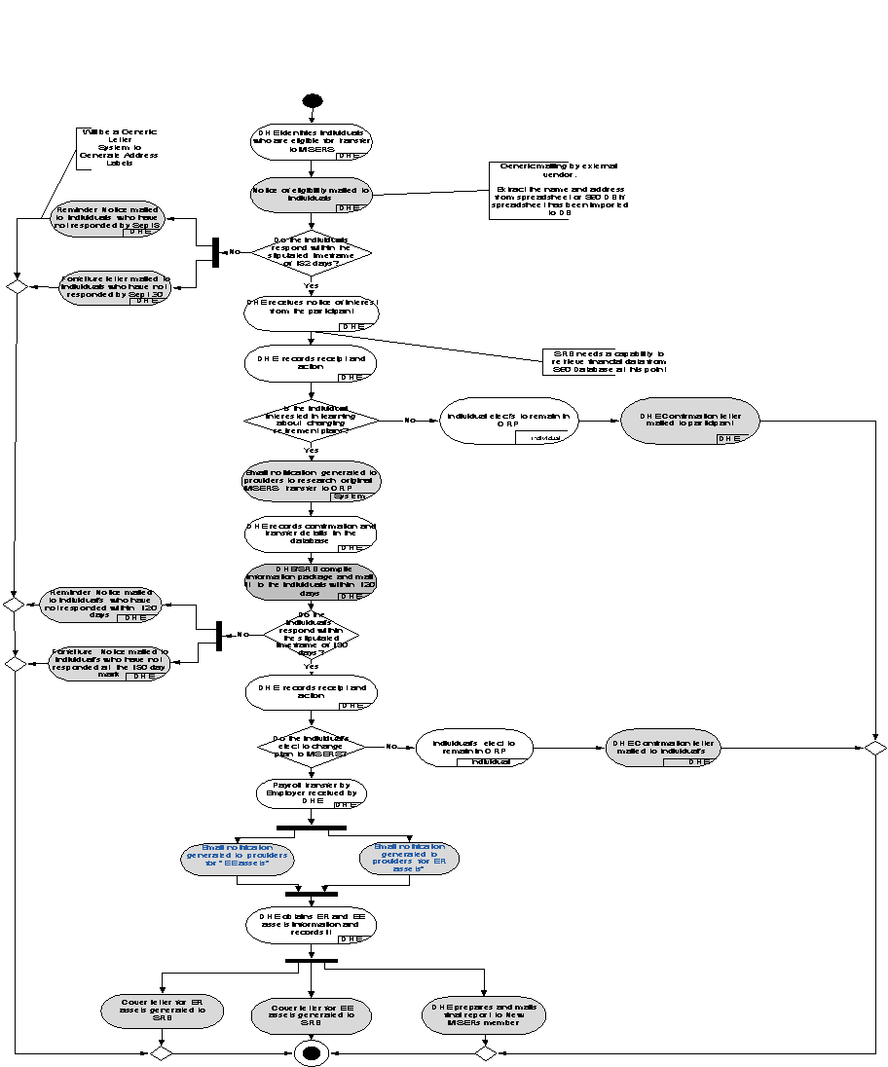

Note: Please reference the appendix for the PDF version of the process flow.

1. **Requirements**
   1. **Conversion of ORP Data to SQL server**
2. (M) The ORP data needs to be imported from a excel sheet and converted to Optional Retirement Transfer Application database.
3. (M) The Payroll data will be extracted from an MS access table.
   1. **Data input of participants from Comma delimited file to ORTA DB**

**3.2.1 Functional Requirements**

1. (M) The initial data input shall be for each pay period until the employee chooses to either remain in the ORP or switch to the pension.
2. M) The Pay Period End date (PPE), calculated base salary, the amount of Employee (“EE”) plan contribution (deduction?) and FTE fields shall be input from Comma delimited file to ORTA DB.
3. (M) The batch process shall run every pay period cycle and shall insert this new data to ORTA DB.

### **Screen Mock Up:**

N/A

* + 1. **Field Related Information for Participants Payroll:**

|  |  |  |  |  |  |
| --- | --- | --- | --- | --- | --- |
| ***Source Database*** | ***Table Name***  ***(Source)*** | ***Field Name***  ***(Source)*** | ***Target Database*** | ***Table Name***  ***(Target)*** | ***Field Name***  ***(Target)*** |
| CIW |  | Pay Period End date(PPE) | ORTA DB |  |  |
| CIW |  | Calculated base | ORTA DB |  |  |
| CIW |  | The amount of Employee (“EE”) plan contribution (deduction?) | ORTA DB |  |  |
| CIW |  | FTE | ORTA DB |  |  |

* + 1. **Field Related Information for Participants Information:**

|  |  |  |  |  |  |
| --- | --- | --- | --- | --- | --- |
| ***Source Database*** | ***Table Name***  ***(Source)*** | ***Field Name***  ***(Source)*** | ***Target Database*** | ***Table Name***  ***(Target)*** | ***Field Name***  ***(Target)*** |
| Excel Sheet | Excel Sheet | Last Name | ORTA DB |  |  |
| Excel Sheet | Excel Sheet | First Name | ORTA DB |  |  |
| Excel Sheet | Excel Sheet | National ID | ORTA DB |  |  |
| Excel Sheet | Excel Sheet | Employee ID | ORTA DB |  |  |
| Excel Sheet | Excel Sheet | Department ID | ORTA DB |  |  |
| Excel Sheet | Excel Sheet | Location Name | ORTA DB |  |  |
| Excel Sheet | Excel Sheet | Date of birth | ORTA DB |  |  |
| Excel Sheet | Excel Sheet | Current Age | ORTA DB |  |  |
| Excel Sheet | Excel Sheet | UMB correction | ORTA DB |  |  |
| Excel Sheet | Excel Sheet | DRO implemented | ORTA DB |  |  |
| Excel Sheet | Excel Sheet | USERRS service | ORTA DB |  |  |
| Excel Sheet | Excel Sheet | Retiring soon | ORTA DB |  |  |
| Excel Sheet | Excel Sheet | Compensation Limit | ORTA DB |  |  |
| Excel Sheet | Excel Sheet | First PPE contribution | ORTA DB |  |  |
| Excel Sheet | Excel Sheet | 10-5-13 contribution | ORTA DB |  |  |
| Excel Sheet | Excel Sheet | Status in CIW | ORTA DB |  |  |
| Excel Sheet | Excel Sheet | Initial ORP status | ORTA DB |  |  |
| Excel Sheet | Excel Sheet | Changed ORP status | ORTA DB |  |  |
| Excel Sheet | Excel Sheet | ORP status change date | ORTA DB |  |  |
| Excel Sheet | Excel Sheet | Address 1 | ORTA DB |  |  |
| Excel Sheet | Excel Sheet | Address 2 | ORTA DB |  |  |
| Excel Sheet | Excel Sheet | Address 3 | ORTA DB |  |  |
| Excel Sheet | Excel Sheet | City | ORTA DB |  |  |
| Excel Sheet | Excel Sheet | State | ORTA DB |  |  |
| Excel Sheet | Excel Sheet | Zip code | ORTA DB |  |  |
| Excel Sheet | Excel Sheet | Current Provider | ORTA DB |  |  |
| Excel Sheet | Excel Sheet | Current Provider 2 | ORTA DB |  |  |
| Excel Sheet | Excel Sheet | Current Provider 3 | ORTA DB |  |  |
| Excel Sheet | Excel Sheet | Lincoln participant 2013 | ORTA DB |  |  |
| Excel Sheet | Excel Sheet | Date Notice of eligibility sent | ORTA DB |  |  |
| Excel Sheet | Excel Sheet | Date Follow up sent | ORTA DB |  |  |
| Excel Sheet | Excel Sheet | Date Forfeiture letter sent | ORTA DB |  |  |
| Excel Sheet | Excel Sheet | Date Notice of interest received | ORTA DB |  |  |

* + 1. **Validation Messages:**

N/A

* + 1. **Screen Control / Navigation Rules**

N/A

* + 1. **Other Details**

N/A

* 1. **Standard Template**
     1. **Functional Requirements**

1. (M) Below standard page format will be used in all the Optional Retirement Transfer application pages.
2. (M) This template will reside within the standard EOE header and DHE footer.
3. (M) Standard EOE header will include first & last name of person logged in, along with an option to logout.
4. (M) Existing usability and webpage designing standards will be used.
5. (M) ORTA standard user shall be able to search participants and view their information.
6. (M) ORTA admin user shall be able to generate diffent kind of reports as well.

* + 1. **Standard ORTA Template for User (Page Mockup)**

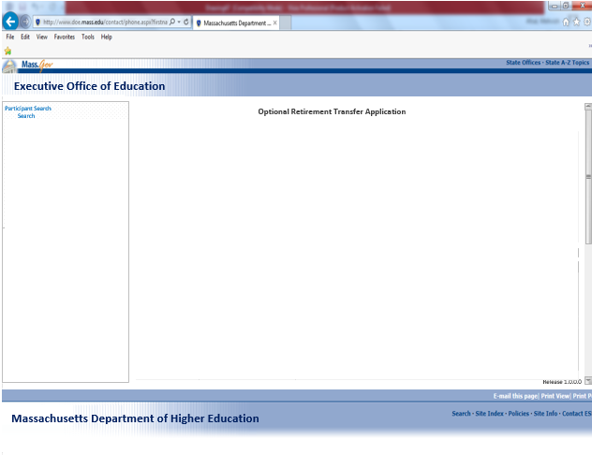

* + 1. **Standard ORTA Template for Administrator (Page Mockup)**

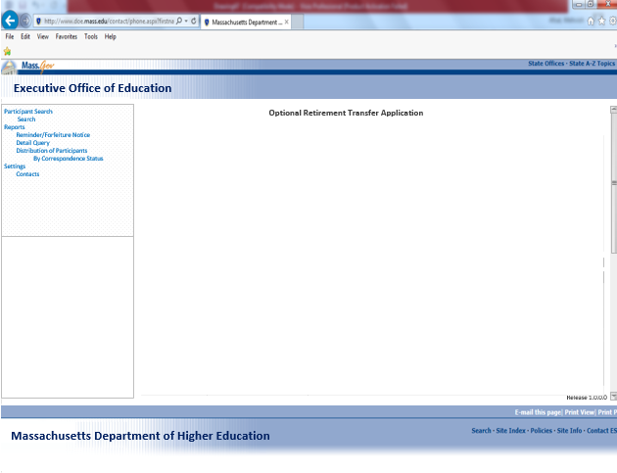

* + 1. **Field Related Information for `Participants Search’**

|  |  |  |  |  |  |  |
| --- | --- | --- | --- | --- | --- | --- |
| ***Field Name*** | ***Input / Output*** | ***Field Size*** | ***Mandatory/ Optional*** | ***Valid Character Type (Special/Alpha Numeric/Numeric)*** | ***Valid Values*** | ***Notes And Format*** |
| Optional Retirement Transfer Application | label | 57 | Mandatory | Alpha | n/a | * This is the application/system header and should be displayed consistently on all pages in the ORTA. |
| Participants Search | label | ~ | Mandatory | Alpha | n/a | * Participants Search is page heading and will change for each page. * Please see each mockup pages (below) for heading info for that page. |
| Search | Navigation Link | 8 | Mandatory | Alpha | n/a | * Search should query ORTA participants basic information as required. * Search results must include: Employee ID, Name, correspondence status and date. * All the data entered/selections made in the search criteria fields must be retained in the fields after search is complete, so that user does not have to enter/select them again after search. * If user has not entered/selected some search criteria and default values have been used for that search. After search is complete, search criteria fields should display the default values used for that particular search. * At least one field is required to do a search. |
| Reports | Navigation Link | 9 | Mandatory | Alpha | n/a | * Link to Reports page. This reports page will have links to all available reports in ORTA. |
| Reminder/Forfeiture Notice Report | Navigation Link | 25 |  |  |  | * Link to Reminder/Forfeiture Notice report page. |
| Detail  Query | Navigation Link | 15 | Mandatory | Alpha | n/a | * Link to Detail Query Report page. |
| Distribution of participants | Navigation Link | 25 | Mandatory | Alpha | n/a | * Link to Distribution of Participants by Status page. |
| Settings | Navigation Link | 9 | Mandatory | Alpha | n/a | * Link to the contacts page. |
| Release 1.0.0.0 | Text | 10 | Mandatory | Alpha Numeric | n/a | * This is the release version and will change with every new release. |

* + 1. **Validation Messages**

|  |  |  |
| --- | --- | --- |
| **Field** | **Condition** | **Message Displayed**  English Text |
| None |  |  |

* + 1. **Screen Flow**

|  |  |  |
| --- | --- | --- |
| **Button / Menu Option / User Navigation** | **Type** | **Action** |
| Participant search | Navigation Link | Navigate to “Participants Search” page, where user will be able to search for participants using search criteria. |
| Search | Navigation Link | Navigate to “Participants Search” page, where user will be able to search for participants using search criteria. |
| Reports | Navigation Link | Navigate user to Reports page, from this page user will be able to access all the reports available in ORTA. This would be similar to a home page for reports. |
| Reminder/Forfeiture Notice Report | Navigation Link | Link to Reminder/Forfeiture Notice report page. |
| Detail Query | Navigation Link | Navigate user to Detail Query Report page. User will be able to view/search/export reports based on a variety of search criteria. |
| Distribution by Correspondence status |  |  |
| Distribution of  Participants | Navigation Link | Navigate user to Distribution of Participant Status page. User will be able to view/search/export reports based on distribution of participants by correspondence status. |
| Settings | Navigation Link | Navigate user to the contacts page. User will be able to view/search/export based on the search criteria. |
| Contacts | Navigation Link | Navigate user to the contacts page. User will be able to view/search/export based on the search criteria. |

* 1. **Participant Search**
     1. **Functional Requirements**

1. (M) System shall display a navigation bar on the left with the `Participant Search’ link.
2. (M) System shall display the participant search with `Search Criteria’ displaying a number of fields listed below.
3. User shall be able to serch by Last name,first name,employee id,Dtae of birth,correspondence statuses ,ssn number and a date range.
4. (M) User shall be able to multi select within the` correspondence Status’ field to broaden the search results.
5. (M) System shall display the `Search results’ in the grid format below the `Search Criteria’.
6. (M) System shall display up to 20 results in the grid table and user shall need to use the scroll to see more results.
7. (M) User shall be able to click on the `Employee ID’ listed in the resukts grid to go to participants detail page.
8. (M) User shall be able to export the `Search results’ in to Excel format.

* + 1. **Screen Mock Up:**

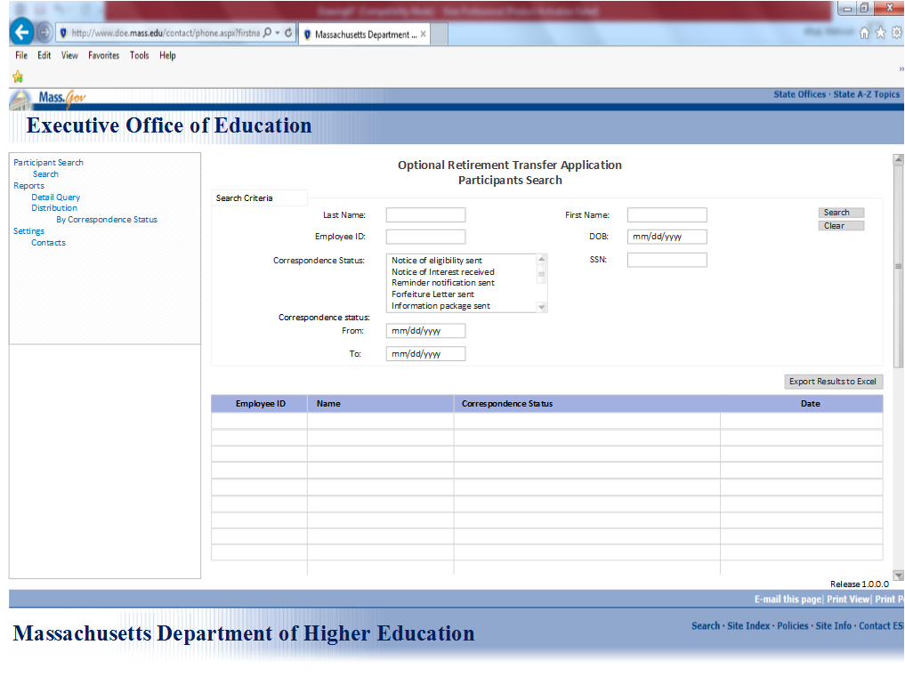

* + 1. **Field Related Information for `Search Criteria’**

|  |  |  |  |  |  |  |
| --- | --- | --- | --- | --- | --- | --- |
| ***Field Name*** | ***Input / Output*** | ***Field Size*** | ***Mandatory/ Optional*** | ***Valid Character Type(/Special/Alpha Numeric/Numeric)*** | ***Valid Values*** | ***Notes And Format*** |
| Participants Search | Page Heading | 19 | Mandatory | Alpha(A-Z, a-z) | n/a | Bold |
| Search  Criteria | Section Heading | 17 | Mandatory | Alpha(A-Z, a-z) | n/a | Bold |
| Last Name | label | 9 | Optional | Alpha(A-Z, a-z) | n/a | * This is the label for the Last Name below |
|  | Field |  | Optional | Alpha(A-Z, a-z) | n/a | * User should be able to do a wildcard search after first letter of the Last Name has be entered E.g. if Letter “A” is entered by the user all cases starting with First Name “B” must be listed. |
| First name | label | 9 | Optional | Alpha(A-Z, a-z) | n/a | * This is the label for First Name below. |
|  | Field | 9 | Optional | Alpha(A-Z, a-z) |  | * User should be able to do a wildcard search after first letter of the First Name has be entered E.g. if Letter “B” is entered by the user all cases starting with First Name “B” must be listed. |
| Employee ID | label | 10 | Optional | Numeric | n/a | * This is the label for Employee ID below. |
|  | Field | 9 | Optional | Numeric |  | * User should be able to type in an employee ID to search for a candidate |
| DOB | label | 9 | Optional | Numeric | n/a | * This is the label for Date of Birth below. |
|  | Field | 9 | Optional | Numeric | n/a | * Format:(mm/dd/yyyy) |
| Correspondence Status | label | 10 | Optional | Alpha(A-Z, a-z) | n/a | * This is the label for correspondence statuses. |
|  | Field | 17 | Optional | Alpha(A-Z, a-z) | n/a | * Correspondence status should display all the statuses available and user shall be able to select one or multiple select. |
| From | label | 9 | Optional | Numeric | n/a | * This is the label to the date selection “From” parameter. |
|  | Field | 9 | Optional | Numeric | n/a | * Format: mm/dd/yyyy * If “To” date is picked, but no “From” date is picked, system should default to1/1/<current year> for from date. * User should be able to select the date using a date picker tool. * User will be able to edit day, month, and year or set it to a blank field. |
| To | label | 9 | Optional | Numeric | n/a | * This is the label for “To” date selection parameter. |
|  | label | 9 | Optional | Numeric | n/a | * Format: mm/did/icy * If no “To” date is picked, system should display all results after picked from date. * User should be able to select the date using a date picker tool. * User will be able to edit day, month, and year or set it to a blank field. |
| Search | Pushbutton | 10 | Mandatory | Alpha(A-Z, a-z) | n/a | * At least one field is required to do a search. |
|  | Pushbutton | 10 | Mandatory | Alpha(A-Z, a-z) | n/a | * Search results must include: Employee ID, Name, Correspondence Status and Status Date. * All the data entered/selections made in the search criteria fields must be retained in the fields after search is complete, so that user does not have to enter/select them again after search. |
| Clear | Pushbutton | 10 | Mandatory | Alpha(A-Z, a-z) | n/a |  |
|  | Pushbutton | 10 | Mandatory | Alpha(A-Z, a-z) | n/a | * Should clear all user inputs and set to defaults |
| Export to excel | Pushbutton | 15 | Mandatory | Alpha(A-Z, a-z) | n/a | * This is a link to execute Excel file. |
|  |  |  |  |  |  | * This button displaying the contents of the result and search criteria has to be included in the XL File. * If search spans to multiple display pages, data from all the pages has to be included in the XL file. * Data order (rows & Columns) in the XL should be in the current Sort Order. |

* + 1. **Validation Messages**

|  |  |  |
| --- | --- | --- |
| **Field** | **Condition** | **Message Displayed**  English Text |
| Search | User must select one criteria to get the search results | You must select one search criteria |
| Date of Birth | User must enter the date in this format mm/dd/yyyy | You must enter the date in this format mm/dd/yyyy |

* + 1. **Screen Flow**

|  |  |  |
| --- | --- | --- |
| **Button / Menu Option / User Navigation** | **Type** | **Action** |
| Search | Pushbutton | Query ORTA with selected search criteria and display results below in grid format. Search results should include Correspondence status and total participants |
| Clear | Pushbutton | Clear all the search criteria entered/selected and will set to default values. |
| Export Results to Excel | Pushbutton | This is a link to execute and download Excel file displaying the contents of the search result and search criteria entered/selected. |

* 1. **Participants Details**
     1. **Functional Requirements**
        1. (M) System shall display `Participants basic information’ along with the correspondence checklist on participants details page.
        2. (M) System shall display the correspondence with all the possible status along with the date fields.
        3. User shall be able to check the box for each step and key in the date based on the latest correspondence received from the participant.

* + 1. **Screen Mock Up:**

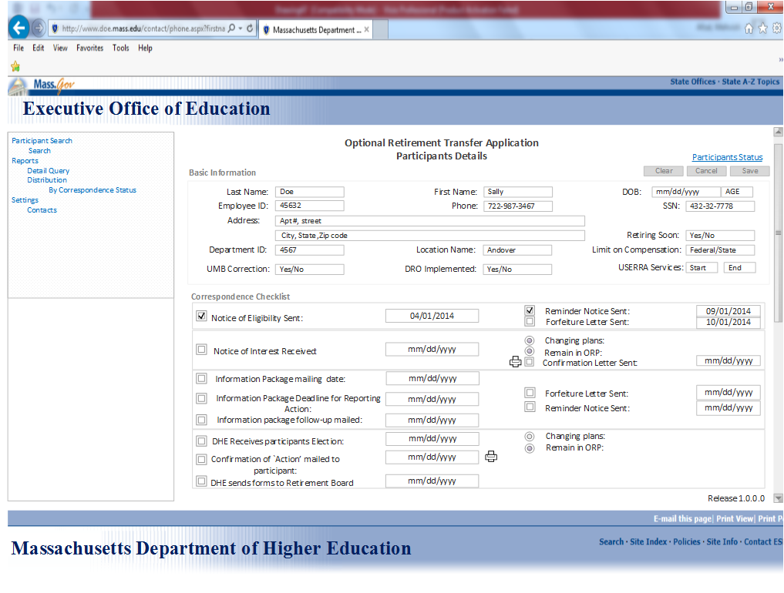

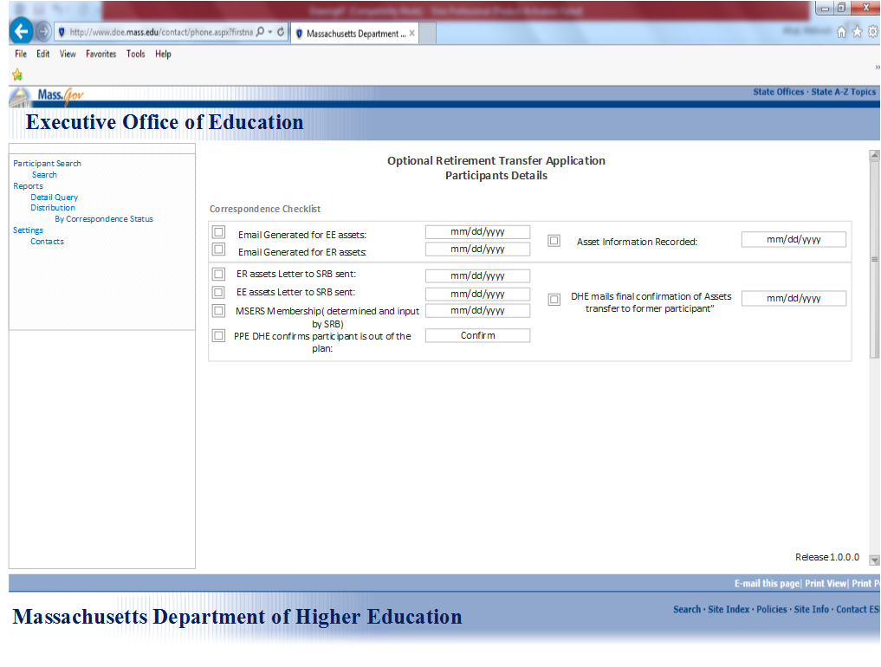

* + 1. **Field Related Information for `Participants basic information’**

|  |  |  |  |  |  |  |
| --- | --- | --- | --- | --- | --- | --- |
| ***Field Name*** | ***Input / Output*** | ***Field Size*** | ***Mandatory/ Optional*** | ***Valid Character Type(/Special/Alpha Numeric/Numeric)*** | ***Valid Values*** | ***Notes And Format*** |
| Participants details | Page  Heading | 19 | Mandatory | Alpha(A-Z, a-z) | n/a | Bold |
| Clear | Pushbutton | 9 | Mandatory | Alpha(A-Z, a-z) | n/a | * This pushbutton will clear all the user entered fields to default values. |
| Cancel | Pushbutton | 9 | Mandatory | Alpha(A-Z, a-z) | n/a | * This pushbutton will cancel adding participant’s details and take the user back to “Participant Search” page. |
| Save | Pushbutton | 9 | Mandatory | Alpha(A-Z, a-z) | n/a | * For existing participants, Save Button will save the changes made to the participants Details page and updates the page. |
| Basic  information | Label | 17 | Mandatory | Alpha(A-Z, a-z) | n/a | Bold |
| Last Name | Label | 17 | Mandatory | Alpha(A-Z, a-z) | n/a | * Label for last Name |
|  | Field | 10 | Mandatory | Alpha(A-Z, a-z) | n/a |  |
| First Name | Label | 17 | Mandatory | Alpha(A-Z, a-z) | n/a | * Label for first name |
|  | Field | 10 | Mandatory | Alpha(A-Z, a-z) | n/a |  |
| Date of Birth | Label | 17 | Mandatory | Numeric | n/a | * Label for Date of birth |
|  | Field | 10 | Mandatory | Numeric | n/a | * This shall display participants date of birth along with age. * Format:   mm/dd/yyyy   * System shall be able to calculate the age based on date of birth entered. |
| Employee ID | Label | 17 | Mandatory | Numeric | n/a |  |
|  | Field | 10 | Mandatory | Numeric | n/a | * This shall display employee ID |
| Phone | Label | 17 | Mandatory | Numeric | n/a | * This shall display participant’s phone number. |
|  | Field | 10 | Mandatory | Numeric | n/a | * Format:   XXX-XXX-XXXX |
| SSN | Label | 17 | Mandatory | Numeric | n/a | * This shall display the social security number of the Participant. |
|  | Field | 10 | Mandatory | Numeric | n/a | * This field cannot be edited/updated by the user. * SSN Display Format: xxx-xx-xxxx |
| Address | Label | 17 | Mandatory | Alpha(A-Z, a-z) | n/a | * This field should display participants address. |
|  | Field | 30 | Mandatory | Alpha(A-Z, a-z) | n/a | * Format:   Apt#,Street,City,State and zip code |
| Retiring soon | Label | 17 | Mandatory | Alpha(A-Z, a-z) | Yes/No |  |
|  | Field | 10 | Mandatory | Alpha(A-Z, a-z) | Yes/No | * This should be a drop down with yes or no option. |
| Department ID | Label | 17 | Mandatory | Numeric | n/a |  |
|  | Field | 10 | Mandatory | Numeric | n/a | * This shall display participants department ID |
| Location Name | Label | 17 | Mandatory | Alpha(A-Z, a-z) | n/a |  |
|  | Field | 15 | Mandatory | Alpha(A-Z, a-z) | n/a | * This shall display participants location where he works |
| Limit on compensation | Label | 17 | Mandatory | Alpha(A-Z, a-z) | n/a |  |
|  | Field | 10 | Mandatory | Alpha(A-Z, a-z) | State/Federal | * Should be a drop down with Federal or state option. |
| UMB correction | Label | 17 | Mandatory | Alpha(A-Z, a-z) |  |  |
|  | Field | 10 | Mandatory | Alpha(A-Z, a-z) | Yes/No | * Should be a drop down with yes or no option. |
| DRO implemented | Label | 17 | Mandatory | Alpha(A-Z, a-z) |  |  |
|  | Field | 10 | Mandatory | Alpha(A-Z, a-z) | Yes/No | * Should be a drop down with yes or no option. |
| USERRA service | Label | 17 | Mandatory | Numeric | Start date/End Date |  |
|  | Field | 10 | Mandatory | Numeric | Start date/End Date | * Should be a start and an end date. |

* + 1. **Validation Messages**

|  |  |  |
| --- | --- | --- |
| **Field** | **Condition** | **Message Displayed**  English Text |
| None |  |  |

* + 1. **Screen Flow**

|  |  |  |
| --- | --- | --- |
| **Button / Menu Option / User Navigation** | **Type** | **Action** |
| Search | Pushbutton | Query ORTA with selected search criteria and display results below in grid format. Search results should include Correspondence status and total participants |
| Clear | Pushbutton | Clear all the Data entered/selected and will set to default values. |
| Cancel | Pushbutton | Cancels all the information entered/selected and will set to default values. |
| Participants Status | Link | This navigates the user to the next page in the application |

* + 1. **Notice of Eligibility**

1. **Functional Requirements**
   * + 1. (M) Notice of Eligibility letter shall be a generic mail sent to all the eligible 3700 participants. The mail would include enclosures, notice of interest form and pre-addressed no 10 return envelope. The printing and mailing of the Notice of eligibility shall be handled by an external vendor.
       2. (M) The address of the 3700 eligible participants needs to be extracted from the ORP database. The related table name and field names are mentioned beneath.

Table Name:

Field Name:

[Validation and normalization of the address is not in scope].

Q1: Since the printing of the notice of eligibility letters is handled by an external vendor how can we keep track of the date it was mailed? Or can we track the date+2 the address labels were generated as the date the Notice of eligibility was printed and mailed.

* + - 1. (M)When the batch job has run successfully the following fields need to be captured in the ORTA DB database -Amped, SSN, Send date (the date label was processed), letter type (Notice of Eligibility-).
    1. **Reminder Letter**
       1. (M) The system shall generate reminder letters for all individuals who have not responded to the Notice of Eligibility within 100 days of mailing it.

RR: How can we identify the individuals who have not responded to the notice of eligibility?

* + - 1. (M) The reminder letter shall be a generic one. The dynamic fields in the letter shall be the Name of the recipient and address. Please see attachment embedded beneath for the letter template.
      2. (M) If the batch job stops in the middle, then the letters need to be reprinted from the start.
      3. (M)The count of letters printed should equal to the count of the individuals who have not responded back to the Notice of eligibility (with a Notice of Interest) within 100 days.
    1. **Forfeiture Letter**
       1. (M) The system shall generate forfeiture letters for all individuals who have not responded to the Notice of Eligibility within the 180 days time period.

RR: How can we identify the individuals who have not responded to the notice of eligibility?

* + - 1. (M) The forfeiture letter shall be a generic one. The dynamic fields in the letter shall be the Name of the recipient and address. Please see attachment embedded beneath for the letter template.
      2. (M) If the batch job stops in the middle, then the letters need to be reprinted from the start.
      3. (M)The count of the letters printed should equal to the count of the individuals who have not responded back to the Notice of eligibility (with a Notice of Interest) within 182 days.

* + 1. **Field Related Information for `Notice of Eligibility’**

|  |  |  |  |  |  |  |
| --- | --- | --- | --- | --- | --- | --- |
| ***Field Name*** | ***Input / Output*** | ***Field Size*** | ***Mandatory/ Optional*** | ***Valid Character Type(/Special/Alpha Numeric/Numeric)*** | ***Valid Values*** | ***Notes And Format*** |
| Notice of  Eligibility sent:  ( | Label | 30 | Mandatory | Numeric | n/a | * This is the first step of the process. |
|  | Field | 10 | Mandatory | Numeric | n/a | * Format:   (mm/dd/yyyy) |
| Reminder  Notice sent | Label | 30 | Mandatory | Numeric | n/a |  |
|  | Field | 10 | Mandatory | Numeric | n/a | * If participant does not respond back in 182 days a reminder letter will be send. * System will capture the date of reminder notice sent. * Format:   (mm/dd/yyyy) |
| Forfeiture  Letter sent: | Label | 30 | Mandatory | Numeric | n/a |  |
|  | Field | 10 | Mandatory | Numeric | n/a | * If participant does not respond back in 100 days of reminder letter sent, a forfeiture letter will be sent to the participant. * After the forfeiture letter participants will no longer be able to change his retirement plan. * System will capture the date of forfeiture letter sent. * Format:   (mm/dd/yyyy) |

* + 1. **Validation Messages**

|  |  |  |
| --- | --- | --- |
| **Field** | **Condition** | **Message Displayed**  English Text |
| None |  |  |

* + 1. **Screen Flow**

|  |  |  |
| --- | --- | --- |
| **Button / Menu Option / User Navigation** | **Type** | **Action** |
|  |  |  |

* + 1. **Notice of Interest received:**

1. **Functional Requirements**
2. (M) The system shall provide a capability for the DHE admin to capture the date for `Notice of interest form’ or the `Notice of election form’ received by DHE. This shall be implemented through the“Correspondance checklist” displayed below.
3. (M) System shall display the date field against `Notice of interest received’ label, to key in the date when the notice of interest form is received from the participants.
4. (M) System shall display the correspondence checklist with two options (changing plans and Remain in ORP) to note down participants decision.
5. If the participant chooses to change his plan from ORP to MSERS the other two options (remain in ORP and confirmation letter) shall be disabled.
6. (M) If the participant chooses to remain in ORP, DHE user shall be able to key in the date for the confirmation letter and push the printer button to print the letter right away.
7. The confirmation letter shall display candidates name and today’s date on it for each participant.

* + 1. **Field Related Information for `Notice of Interest’**

|  |  |  |  |  |  |  |
| --- | --- | --- | --- | --- | --- | --- |
| ***Field Name*** | ***Input / Output*** | ***Field Size*** | ***Mandatory/ Optional*** | ***Valid Character Type(/Special/Alpha Numeric/Numeric)*** | ***Valid Values*** | ***Notes And Format*** |
| Notice of  Interest  received | Label | 30 | Mandatory | Numeric | n/a |  |
|  | Field | 10 | Mandatory | Numeric | n/a | * This is the second step of the process * Format:   (mm/dd/yyyy) |
| Change Plan | Label | 30 | Optional | Alpha(A-Z, a-z) |  |  |
|  | Field | 10 | Optional | Alpha(A-Z, a-z) | * Transfer to * MSERS * Remain in ORP | * If the user opts to change his plan to MSERS the other two options will be disabled and user will be sent an information package with more information about MSERS. |
| Confirmation  Letter sent | Label | 30 | Optional | Alpha(A-Z, a-z) | Remain in ORP |  |
|  | Field | 10 | Optional | Alpha(A-Z, a-z) | Remain in ORP | * If the participant chooses to stay in ORP, User shall be able to send a confirmation letter with participants name and today’s date. |

* + 1. **Validation Messages**

|  |  |  |
| --- | --- | --- |
| **Field** | **Condition** | **Message Displayed**  English Text |
| Confirmation Letter | User must put in the date before pressing print button to print the letter | You must key in the date for the letter to get printed. |

* + 1. **Screen Flow**

|  |  |  |
| --- | --- | --- |
| **Button / Menu Option / User Navigation** | **Type** | **Action** |
| Print | Pushbutton | If a participant opts to stay in ORP, the DHE user will key in the date and push the print button to print the letter of confirmation. |

* + 1. **Information Package**

1. **Functional Requirements:**
2. (M) Participants who choose to change their plan to MSERS shall receive an information package compiled by DHE user with all the MSERS information.
3. (M) The system shall automatically calculate and display the Information package due date based on the notice of interest Received date.
4. (M) DHE shall be able to compile the information package within 120 days of `Notice of interest received’ in favor of MSERS.
5. (M) The information package would include a three page statement of qualifying service and cost, one page statement of status under ORP vs. Retiree in Eligibility, one page list of resources, Election form, MSERS application, one page explanation of what happens next (changing plans) and a large pre-addressed return envelope. Attached beneath is a sample template.
6. (M)In the three page statement of qualifying service and cost enclosure the following fields i.e. ‘Amount of Qualifying Service available’, ‘Cost to purchase the service’, ‘Effective date of the Service and cost data’, ‘ total amount of “Employee” assets in the ORP’, ‘Effective date of the “Employee” asset balance reported’, and ‘Date by which reply must be received at the DHE’ are dynamic and needs to be populated with the data provided in the “Compile Information Package “ page.

Q1: From where is this data obtained and calculated? Do the providers email this information to DHE?

Q2: From where is this data obtained and calculated? Do the providers email this information to DHE?

1. (M)The count of the letters printed should equal to the count of the individuals who have responded to the Notice of Interest and whose information package has been compiled.

Q3: Should these letters be printed as and when they compile the information package or on weekly basis?

1. (M) The address of the individuals for information package to be sent needs to be extracted from the ORP database. The related table name and field name is mentioned beneath.

Table Name:

Field Name:

1. (M) Batch job shall generate the address labels and send to printer XXXX.
2. (M) The font type and size of the Address shall be Arial 10.
3. (M) The format of the Address printed on the address label shall be as indicated beneath Apt#, Street name, City, state and zip code.

**Business Rule:**

1. If the “status = Notice of Interest Received” and “Received Date =MM/DD/YYYY” then the system should calculate and display the Information package due date which is MM/DD/YYYY+ 120 or 119? Days.

**Reminder Letter**

1. (M) The system shall generate reminder letters for all individuals who have not responded to the Information package within 90 days of receiving it.

RR: How can we identify the individuals who have not responded to the information package? [Query- Update individual status where status is not equal to ‘Received Notice of Election’ and passed ‘sent date (from correspondence history) +90 days’.]

1. (M) System shall be able to key in the reminder notice date based on the information package mailing date.
2. (M) If participant fails to respond within 120 days of information package sent date, system shall be able to send the reminder notice.
3. (M) The reminder letter shall be a generic one. The dynamic fields in the letter shall be the Name of the recipient and address.
4. (M) If the batch job stops in the middle, then the letters need to be reprinted from the start.
5. (M)The count of the letters printed should equal to the count of the individuals who have not responded to the Information package with an Election form within 100 days in the ORTA DB database.

**Forfeiture Letter**

1. (M) If participant fails to respond within 80 days of reminder notice sent date, system shall be able to send the forfeiture letter and the participant will no longer be able to change his retirement plan thereafter.

RR: How can we identify the individuals who have not responded to the information package? [Query- Update individual status where status is not equal to ‘Received Notice of Election’ and passed ‘sent date (from correspondence history) +180 days’.]

1. (M) The forfeiture letter shall be a generic one. The dynamic fields in the letter shall be the Name of the recipient and address. Please see attachment embedded beneath for the letter template.
2. (M) If the batch job stops in the middle, then the letters need to be reprinted from the start.
3. (M)The count of the letters printed should equal to the count of the individuals who have not responded back to the information package with an election form within 180 days.

**Business Rules:**

1. If the current date-information package mailing date is > 180 days send a forfeiture letter to the participant.
2. If the current date – information package mailing date is >100 system will send a reminder notice.

* + 1. **Field Related Information for `Information Package’**

|  |  |  |  |  |  |  |
| --- | --- | --- | --- | --- | --- | --- |
| ***Field Name*** | ***Input / Output*** | ***Field Size*** | ***Mandatory/ Optional*** | ***Valid Character Type(/Special/Alpha Numeric/Numeric)*** | ***Valid Values*** | ***Notes And Format*** |
| Information Package mailing date | Label | 19 | Mandatory | Numeric | n/a |  |
|  | Field | 10 | Mandatory | Numeric |  | * This is the date when DHE will send the information package to the participants |
| Reminder Notice | Label | 30 | Mandatory | Alpha | n/a |  |
|  | Field | 10 |  | Numeric | n/a | * Based on the information package mailed date system will key in the date for information package deadline for reporting action. (Calculating 100 days from the mailing date). * If the current date – information package mailing date is >100 system will send a reminder notice. |
| Forfeiture  Letter | Label | 30 | Mandatory | Alpha | n/a |  |
|  | Field | 10 | Mandatory | Numeric | n/a | * If the current date-information package mailing date is > 180 days send a forfeiture letter to the participant. |

* + 1. **Participants Election form:**

1. **Functional Requirements:**
2. (M) DHE shall receive an election form from each participant indicating their choice of moving to MSERS or Remain in ORP.
3. (M) DHE user shall be able to key in the `Date’ of election form received and their action of choice.
4. (M) If the participant chooses to move to MSERS, DHE user shall start to gather his assets information from his providers.
5. (M) If the participant chooses to stay in ORP,DHE user shall be able to key in the date and print a confirmation of `Action’ letter to be mailed to the participant indicating their choice to stay in ORP and they are no longer eligible to change their plan at any point of time thereafter.

* + 1. **Field Related Information for `Participants Election form’**

|  |  |  |  |  |  |  |
| --- | --- | --- | --- | --- | --- | --- |
| ***Field Name*** | ***Input / Output*** | ***Field Size*** | ***Mandatory/ Optional*** | ***Valid Character Type(/Special/Alpha Numeric/Numeric)*** | ***Valid Values*** | ***Notes And Format*** |
| DHE Receives participants election | Label | 30 | Mandatory | Numeric | n/a | * This is the third step of the process |
|  | Field | 10 | Mandatory | Numeric | n/a | * Format:   (mm/dd/yyyy) |
| Change Plan | Label | 30 | Optional | Alpha(A-Z, a-z) | * Transfer to * MSERS * Remain in ORP |  |
|  | Field | 10 | Optional | Alpha(A-Z, a-z) | * Transfer to * MSERS * Remain in ORP | * If the user opts to change his plan to MSERS the other two options will be disabled and user will be sent an information package with information about MSERS. |
| Confirmation Letter sent | Label | 30 | Optional | Alpha(A-Z, a-z) |  |  |
|  | Field | 10 | Optional | Alpha(A-Z, a-z) | Remain in ORP | * If choose to stay in ORP,sents a confirmation letter |

* + 1. **Validation Messages**

|  |  |  |
| --- | --- | --- |
| **Field** | **Condition** | **Message Displayed**  English Text |
| None |  |  |

* + 1. **Screen Flow**

|  |  |  |
| --- | --- | --- |
| **Button / Menu Option / User Navigation** | **Type** | **Action** |
| Print |  | If a participant opts to stay in ORP, the DHE user will key in the date and push the print button to print the letter of confirmation. |

* + 1. **MSERS Enrollment**

1. **Functional Requirements**
2. (M) DHE user shall be able to generate an email to employees current and former providers to gather employee funds information for the participant.
3. (M) DHE user shall be able to send an email with regards to employee assets to his employer and gather all the required retirement funds information for the participnat.This email will be sent to SRB?
4. DHE user shall be able to record the date for both emails, to the employer and to providers in the correspondence checklist to keep track to all the correspondence.
5. The system shall automatically calculate and display the MSERS Enrollment due date based on the Election form Received date and change plan values associated with the Election form.

**Business rules**

1. If the “status = Election form Received”, “Received Date =MM/DD/YYYY” and “Change Plan=Transfer to MSERS” then the system should calculate and display the MSER Enrollment due date which is MM/DD/YYYY+ 90 or 89? Days.

* + 1. **Field Related Information:**

|  |  |  |  |  |  |  |
| --- | --- | --- | --- | --- | --- | --- |
| ***Field Name*** | ***Input / Output*** | ***Field Size*** | ***Mandatory/ Optional*** | ***Valid Character Type(/Special/Alpha Numeric/Numeric)*** | ***Valid Values*** | ***Notes And Format*** |
| Email  generated  to EE assets | Label | 30 | Mandatory | Numeric | n/a |  |
|  | Field | 10 | Mandatory | Numeric | n/a | * An email will be generated by DHE user to Employee for the Asset information. The email sent date keyed in the application |
| Email  generated  to ER assets | Label | 30 | Mandatory | Numeric | n/a |  |
|  | Field | 10 | Mandatory | Numeric | n/a | * An email will be generated by DHE user to Employer for the Asset information. The email sent date will be keyed in the application |
| Asset information Recorded | Label | 30 | Mandatory | Numeric | n/a |  |
|  | Field | 10 | Mandatory | Numeric | n/a | * This will key in the date when both the EE and ER asset information will be recorded in the application. |

* + 1. **DHE Confirmation letter**

1. **Functional Requirements:**
2. (M) DHE user shall be able to sent Employer assets letter for each participant to SRB.
3. (M) DHE user shall be able to sent Employee assets letter for each participant to SRB.
4. (M) SRB shall determine MSERS membership date for the participants and key it in to the ORTApplication.
5. (M) DHE shall confirm that the participant is out of his previous plan.
6. (M) DHE shall be able to send a final confirmation of assets transfer to the former participant.
7. (M) The DHE Confirmation letter shall be a generic one. The dynamic fields in the letter shall be the Name of the recipient and address.
8. (M) If the batch job stops in the middle, then the letters need to be reprinted from the start.
9. (M)The count of the letters printed should equal to the count of the individuals who have responded to the Information package with an Election form and who have indicated an interest in remaining in ORP.
   * 1. **Field Related Information:**

|  |  |  |  |  |  |  |
| --- | --- | --- | --- | --- | --- | --- |
| ***Field Name*** | ***Input / Output*** | ***Field Size*** | ***Mandatory/ Optional*** | ***Valid Character Type(/Special/Alpha Numeric/Numeric)*** | ***Valid Values*** | ***Notes And Format*** |
| ER assets letter to SRB sent | Label | 30 | Mandatory | Numeric | n/a |  |
|  | Field | 10 | Mandatory | Numeric | n/a | * DHE user shall be able to sent Employer assets letter for each participant to SRB. |
| EE assets letter to SRB sent | Label | 30 | Mandatory | Numeric | n/a |  |
|  | Field | 10 | Mandatory | Numeric | n/a | * DHE user shall be able to sent Employee assets letter for each participant to SRB. |
| MSERS membership(determined and input by SRB) | Label | 30 | Mandatory | Numeric | n/a |  |
|  | Field | 10 | Mandatory | Numeric | n/a | * SRB shall determine MSERS membership date for the participants and key it in to the ORTApplication. |
| PPE DHE confirms participant is out of the plan | Label | 30 | Mandatory | Numeric | n/a |  |
|  | Field | 10 | Mandatory | Numeric | n/a | * DHE shall confirm that the participant is out of his previous plan. |
| DHE mails final confirmation of assets transfer to former participant. | Label | 30 | Mandatory | Numeric | n/a |  |
|  | Field | 10 | Mandatory | Numeric | n/a | * DHE shall be able to send a final confirmation of assets transfer to the former participant. |

* + 1. **Validation Messages:**

|  |  |  |
| --- | --- | --- |
| **Field** | **Condition** | **Message Displayed**  English Text |
| None |  |  |

* + 1. **Screen Flow**

|  |  |  |
| --- | --- | --- |
| **Button / Menu Option / User Navigation** | **Type** | **Action** |
| None |  |  |

* 1. **Participants status:**
     1. **Functional Requirements**

1. (M) System shall display participants’ status information page with current and previous providers along with their contact information.

* + 1. **Screen Mock Up:**

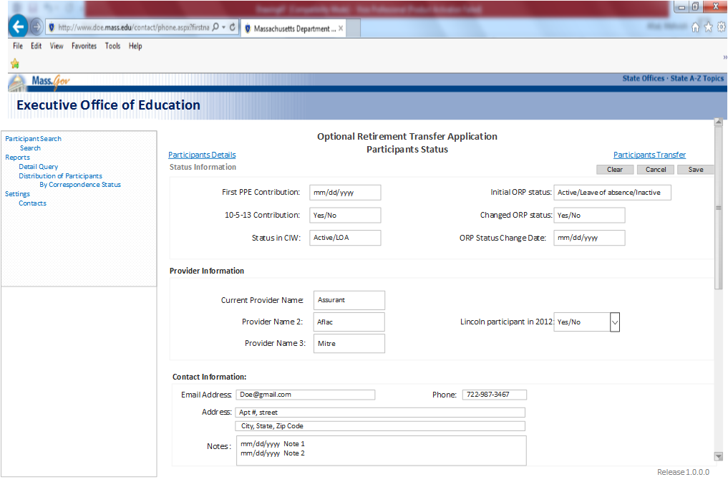

* + 1. **Field Related Information for `Participants Status’**

|  |  |  |  |  |  |  |
| --- | --- | --- | --- | --- | --- | --- |
| ***Field Name*** | ***Input / Output*** | ***Field Size*** | ***Mandatory/ Optional*** | ***Valid Character Type(/Special/Alpha Numeric/Numeric)*** | ***Valid Values*** | ***Notes And Format*** |
| Participants Status | Page  Heading | 19 | Mandatory | Alpha(A-Z, a-z) | n/a | Bold |
| Status information | Section  Heading | 19 | Mandatory | Alpha(A-Z, a-z) | n/a | Bold |
| First PPE Contribution | Label | 17 | Mandatory | Numeric | n/a |  |
|  | Field | 10 | Mandatory | Numeric | n/a | * Format: (mm/dd/yyyy) |
| Initial ORP  status | Label | 9 | Mandatory | Alpha(A-Z, a-z) | * Active * Leave of absence * Inactive |  |
|  | field | 10 | Mandatory | Alpha(A-Z, a-z) |  | * This shall display a dropdown with these three options. User shall be able to choose only one option. |
| 10-5-13  contribution | Label | 17 | Mandatory | Alpha(A-Z, a-z) | Yes/No |  |
|  | field | 10 | Mandatory | Alpha(A-Z, a-z) | Yes/No |  |
| Changed ORP  status | Label | 17 | Mandatory | Alpha(A-Z, a-z) | Yes/No |  |
|  | field | 10 | Mandatory | Alpha(A-Z, a-z) | Yes/No |  |
| Status in CIW | Label | 17 | Mandatory | Alpha(A-Z, a-z) | Active/LOA |  |
|  | field | 10 | Mandatory | Alpha(A-Z, a-z) | Active/LOA |  |
| ORP status change date | Label | 17 | Mandatory | Numeric | n/a |  |
|  | Field | 10 | Mandatory | Numeric | n/a | * Format: (mm/dd/yyyy) |

* + 1. **Field Related Information for `Provider information’**

|  |  |  |  |  |  |  |
| --- | --- | --- | --- | --- | --- | --- |
| ***Field Name*** | ***Input / Output*** | ***Field Size*** | ***Mandatory/ Optional*** | ***Valid Character Type(/Special/Alpha Numeric/Numeric)*** | ***Valid Values*** | ***Notes And Format*** |
| Provider Information | Section  Heading | 17 | Mandatory | Alpha(A-Z, a-z) | n/a | Bold |
| Current provider name | Label | 17 | Mandatory | Alpha(A-Z, a-z) | n/a |  |
|  | Field | 10 | Mandatory | Alpha(A-Z, a-z) | n/a | * This shall display the name of the current provider. |
| Provider Name 2 | Label | 17 | Mandatory | Alpha(A-Z, a-z) | n/a |  |
|  | Field | 10 | Mandatory | Alpha(A-Z, a-z) | n/a | * This shall display the name of provider 2. |
| Provider Name 3 | Label | 17 | Mandatory | Alpha(A-Z, a-z) | n/a |  |
|  | Field | 10 | Mandatory | Alpha(A-Z, a-z) | n/a | * This shall display the name of provider 3. |
| Lincoln participants in  2012 | Label | 17 | Mandatory | Alpha(A-Z, a-z) | Yes/No |  |
|  | Field | 10 | Mandatory | Alpha(A-Z, a-z) | Yes/No |  |

* + 1. **Field Related Information for `Providers Contact information’**

|  |  |  |  |  |  |  |
| --- | --- | --- | --- | --- | --- | --- |
| ***Field Name*** | ***Input / Output*** | ***Field Size*** | ***Mandatory/ Optional*** | ***Valid Character Type(/Special/Alpha Numeric/Numeric)*** | ***Valid Values*** | ***Notes And Format*** |
| Contact information | Table  heading | 17 | Mandatory | Alpha(A-Z, a-z) | n/a | * Bold |
| Email Address | Label | 17 | Mandatory | Alpha numeric | n/a |  |
|  | Field | 17 | Mandatory | Alpha numeric | n/a | * Format:Doe@gmail.com |
| Address | Label | 9 | Mandatory | Alpha numeric | n/a |  |
|  | Field | 30 | Mandatory | Alpha numeric | n/a | * Format: Apt#,Street.City,State,zipcode |
| Phone | Label | 9 | Mandatory | numeric | n/a |  |
|  | Field | 9 | Mandatory | numeric | n/a | * Format:XXX-XXX-XXXX |
| Notes with date | Label | 17 | Mandatory | Alpha numeric | n/a |  |
|  | Field | 50 | Mandatory | Alpha numeric | n/a | * Free form Text with date   (dd/mm/yyyy) |

* + 1. **Validation Messages:**

|  |  |  |
| --- | --- | --- |
| **Field** | **Condition** | **Message Displayed**  English Text |
| None |  |  |

* + 1. **Screen Flow**

|  |  |  |
| --- | --- | --- |
| **Button / Menu Option / User Navigation** | **Type** | **Action** |
| Participants Transfer | Link | Should take the user to the next page in the application (participant transfer). |
| Participants Details | Link | Should take the user back to participant details page. |
| Clear | Pushbutton | Clear all the search criteria entered/selected and will set to default values. |
| Cancel | Pushbutton | Cancel all the information entered and will set to default values |
| Save | Pushbutton | Saves all the information entered for the page. |

* 1. **Participants Transfer:**
     1. **Functional Requirements**

1. System shall display a `Participants transfer’ page with `MSERS transfer to ORP’ and `Qualifying services and cost’ fields.

* + 1. **Screen Mock Up:**

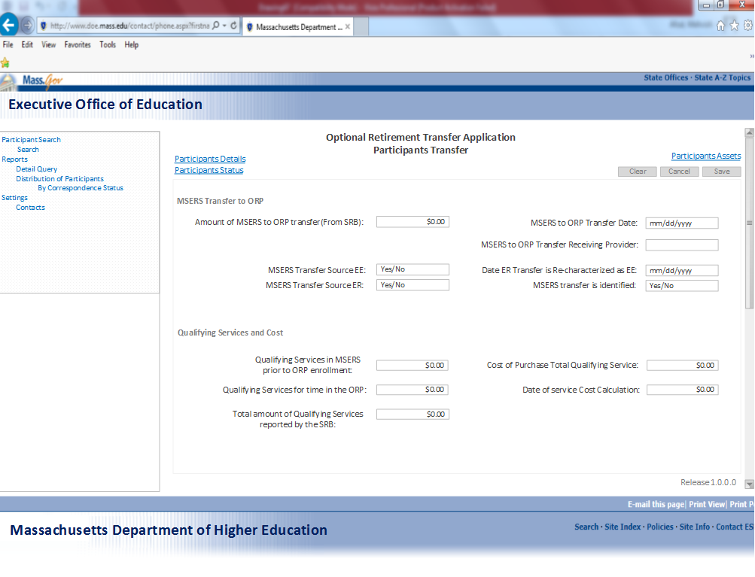

* + 1. **Field Related Information for participants transfer `MSERS Transfer to ORP’**

|  |  |  |  |  |  |  |
| --- | --- | --- | --- | --- | --- | --- |
| ***Field Name*** | ***Input / Output*** | ***Field Size*** | ***Mandatory/ Optional*** | ***Valid Character Type(/Special/Alpha Numeric/Numeric)*** | ***Valid Values*** | ***Notes And Format*** |
| Participants transfer | Label | 19 | Mandatory | Alpha(A-Z, a-z) | n/a | Bold |
| MSERS transfer to ORP | Section  Heading | 17 | Mandatory | Alpha(A-Z, a-z) | n/a | Bold |
| Amount of MSERS to ORP transfer | Label | 17 | Mandatory | Numeric | n/a |  |
|  | Fields | 9 | Mandatory | Numeric | n/a | * The input in this field should be a $ amount. |
| MSERS to ORP transfer date | Label | 17 | Mandatory | Numeric | n/a |  |
|  | Field | 9 | Mandatory | Numeric | n/a | * Format:(mm/dd/yyyy) |
| MSERS to ORP transfer receiving provider | Label | 17 | Mandatory | Alpha(A-Z, a-z) | n/a |  |
|  | Field | 9 | Mandatory | Alpha(A-Z, a-z) | n/a | * This shall display the name of transfer receiving provider from MSERS to ORP |
| MSERS transfer source EE | Label | 17 | Mandatory | Alpha(A-Z, a-z) | n/a |  |
|  | Filed | 9 | Mandatory | Alpha(A-Z, a-z) | Yes/No |  |
| MSERS transfer source ER | Label | 17 | Mandatory | Alpha(A-Z, a-z) | n/a |  |
|  |  | 9 | Mandatory | Alpha(A-Z, a-z) | Yes/No |  |
| Date ER transfer is re characterized as EE | Label | 17 | Mandatory | Numeric | n/a |  |
|  |  | 9 | Mandatory | Numeric | n/a | * Format:(mm/dd/yyyy) |
| MSERS transfer is identified | Label | 17 | Mandatory | Alpha(A-Z, a-z) | n/a |  |
|  | Field | 9 | Mandatory | Alpha(A-Z, a-z) | Yes/No |  |

* + 1. **Field Related Information for `Qualifying Service and cost’**

|  |  |  |  |  |  |  |
| --- | --- | --- | --- | --- | --- | --- |
| ***Field Name*** | ***Input / Output*** | ***Field Size*** | ***Mandatory/ Optional*** | ***Valid Character Type(/Special/Alpha Numeric/Numeric)*** | ***Valid Values*** | ***Notes And Format*** |
| Qualifying services and cost | Section  Heading | 17 | Mandatory | Alpha(A-Z, a-z) | n/a | Bold |
| Qualifying services in MSERS prior to ORP enrollment | Label | 17 | Mandatory | Numeric | n/a |  |
|  | Field | 1 10 | Mandatory | Numeric | n/a | * The input in this field should be a $ amount. |
| Qualifying services for time in the ORP | Label | 17 | Mandatory | Numeric | n/a |  |
|  | Field | 10 | Mandatory | Numeric | n/a | * The input in this field should be a $ amount. |
| Total amount of Qualifying services reported by SRB | Label | 17 | Mandatory | Numeric | n/a |  |
|  | Field | 10 | Mandatory | Numeric | n/a | * The input in this field should be a $ amount. |
| Cost of purchase total qualifying service | Label | 17 | Mandatory | Numeric | n/a |  |
|  | Field | 10 | Mandatory | Numeric | n/a | * The input in this field should be in $ amount. |
| Date of service cost calculation | Label | 17 | Mandatory | Numeric | n/a |  |
|  | Field | 10 | Mandatory | Numeric | n/a | * Format:(mm/dd/yyyy) |

* + 1. **Validation Messages:**

|  |  |  |
| --- | --- | --- |
| **Field** | **Condition** | **Message Displayed**  English Text |
| None |  |  |

* + 1. **Screen Flow**

|  |  |  |
| --- | --- | --- |
| **Button / Menu Option / User Navigation** | **Type** | **Action** |
| Participants Assets | Link | Should take the user to the next page in the application (participant assets). |
| Participants Status | Link | Should take the user back to participant status page. |
| Participants Details | Link | Should take the user back to participant details page. |
| Clear | Pushbutton | Clear all the search criteria entered/selected and will set to default values. |
| Cancel | Pushbutton | Cancel all the information entered and will set to default values |
| Save | Pushbutton | Saves all the information entered for the page. |

* 1. **Participants Assets:**
     1. **Functional Requirements**

1. System shall display participants’ asset information page for DHE user.
2. System shall display fields for current employee assets, Employee assets transfer and employee assets recovery.
3. DHE user shall be able to key in this information based on the payroll information from employee and his provider.

* + 1. **Screen Mock Up:**

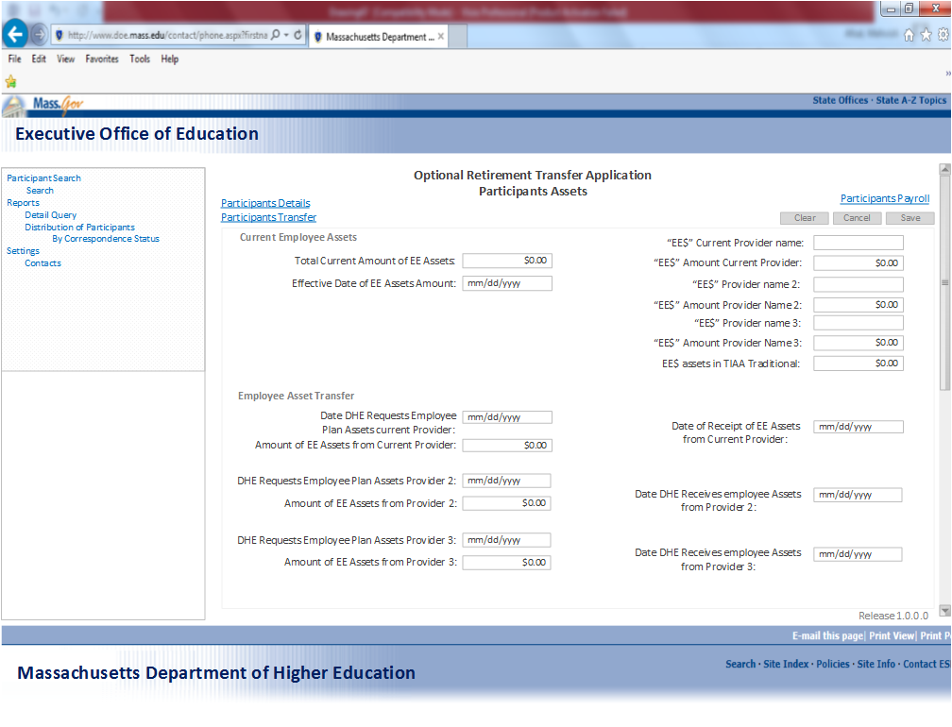

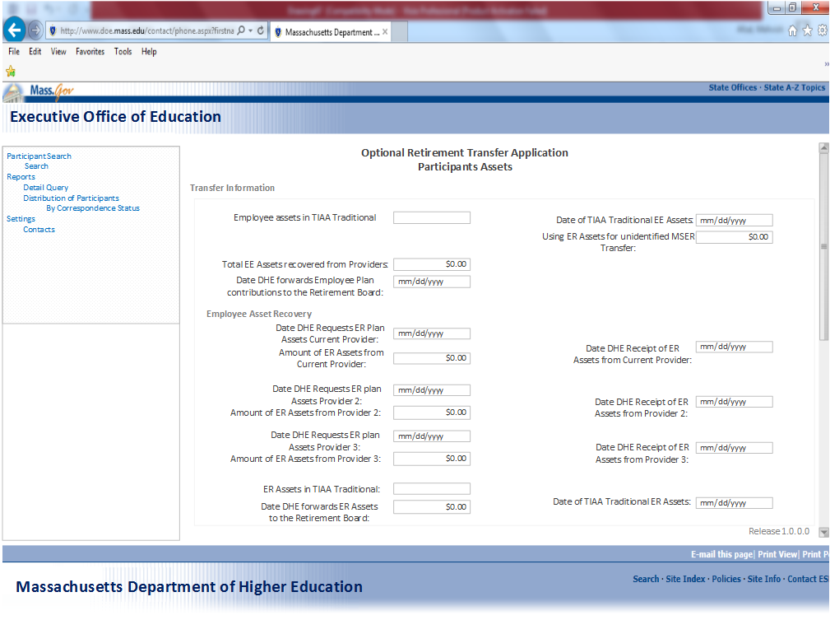

* + 1. **Field Related Information for `Current employee Assets’**

|  |  |  |  |  |  |  |
| --- | --- | --- | --- | --- | --- | --- |
| ***Field Name*** | ***Input / Output*** | ***Field Size*** | ***Mandatory/ Optional*** | ***Valid Character Type(/Special/Alpha Numeric/Numeric)*** | ***Valid Values*** | ***Notes And Format*** |
| Participants Assets | Page  Heading | 30 | Mandatory | Alpha(A-Z, a-z) | n/a | Bold |
| Current employee assets | Section  heading | 17 | Mandatory | Alpha(A-Z, a-z) | n/a | Bold |
| Total current amount of EE assets | Label | 9 | Mandatory | Numeric | n/a |  |
|  | Field | 10 | Mandatory | Numeric | n/a | * The input in this field should be a $ amount. |
| Effective date of EE assets Amount | Label | 9 | Mandatory | Alpha(A-Z, a-z) | n/a |  |
|  | Field | 10 | Mandatory | Alpha(A-Z, a-z) | n/a | * Format:(mm/dd/yyyy) |
| EE$ current provider name | Label | 9 | Mandatory | Alpha(A-Z, a-z) | n/a |  |
|  | Field | 10 | Mandatory | Alpha(A-Z, a-z) | n/a | * This shall display the name of employees current provider. |
| EE$ amount current provider | Label | 9 | Mandatory | Numeric | n/a |  |
|  | Field | 10 | Mandatory | Numeric | n/a | * The input in this field should be a $ amount. |
| EE$ Provider name 2 | Label | 9 | Mandatory | Alpha(A-Z, a-z) | n/a |  |
|  | Field | 10 | Mandatory | Alpha(A-Z, a-z) | n/a | * This shall display the name of employee provider 2. |
| EE$ amount provider Name 2 | Label | 9 | Mandatory | Numeric | n/a |  |
|  | Field | 10 | Mandatory | Numeric | n/a | * This shall display the name of employee provider 2. |
| EE$ Provider name 3 | Label | 9 | Mandatory | Alpha(A-Z, a-z) | n/a |  |
|  | Field | 10 | Mandatory | Alpha(A-Z, a-z) | n/a | * This shall display the name of employee provider 3. |
| EE$ amount provider name 3 | Label | 9 | Mandatory | Numeric | n/a |  |
|  | Field | 10 | Mandatory | Alpha(A-Z, a-z) | n/a | * The input in this field should be a $ amount. |
| EE$ assets in TIAA traditional | Label | 9 | Mandatory | Numeric | n/a |  |
|  | Field | 10 | Mandatory | Alpha(A-Z, a-z) | n/a | * The input in this field should be a $ amount. |

* + 1. **Field Related Information for `Employee Asset transfer’**

|  |  |  |  |  |  |  |
| --- | --- | --- | --- | --- | --- | --- |
| ***Field Name*** | ***Input / Output*** | ***Field Size*** | ***Mandatory/ Optional*** | ***Valid Character Type(/Special/Alpha Numeric/Numeric)*** | ***Valid Values*** | ***Notes And Format*** |
| Employee assets  Transfer | Table heading | 17 | Mandatory | Alpha(A-Z, a-z) | n/a | Bold |
| Date DHE requests employee plan assets current provider | Label | 17 | Mandatory | Alpha | n/a |  |
|  | Field | 10 | Mandatory | Numeric | n/a | * Format:(mm/dd/yyyy) |
| Amount of EE assets from current provider | Label | 17 | Mandatory | Numeric | n/a |  |
|  | Field | 10 | Mandatory | Numeric | n/a | * The input in this field should be a $ amount. |
| Date of receipt of EE Assets from current provider | Label | 17 | Mandatory | Numeric | n/a |  |
|  | Field | 10 | Mandatory | Numeric | n/a | * Format:(mm/dd/yyyy) |
| Date DHE requests employee plan assets provider 2 | Label | 17 | Mandatory | Numeric | n/a |  |
|  | Field | 10 | Mandatory | Numeric | n/a | * Format:(mm/dd/yyyy) |
| Amount of EE assets from provider 2 | Label | 17 | Mandatory | Numeric | n/a |  |
|  | Field | 10 | Mandatory | Numeric | n/a | * The input in this field should be a $ amount. |
| Date DHE receivers employee Assets from Provider 2 | Label | 9 | Mandatory | Numeric | n/a |  |
|  | Field | 10 | Mandatory | Numeric | n/a | * Format:(mm/dd/yyyy) |
| Date DHE requests employee plan assets provider 3 | Label | 17 | Mandatory | Numeric | n/a |  |
|  | Field | 10 | Mandatory | Numeric | n/a | * Format:(mm/dd/yyyy) |
| Amount of EE assets from provider 3 | Label | 17 | Mandatory | Numeric | n/a |  |
|  | Field | 10 | Mandatory | Numeric | n/a | * The input in this field should be in $ amount. |
| Date DHE receivers employee Assets from provider 3 | Label | 17 | Mandatory | Numeric | n/a |  |
|  | Field | 10 | Mandatory | Numeric | n/a | * Format:(mm/dd/yyyy) |
| Employee assets in TIAA traditional | Label | 17 | Mandatory |  | n/a |  |
|  | Field | 10 | Mandatory |  | n/a |  |
| Date of TIAA traditional EE assets | Label | 17 | Mandatory | Numeric | n/a |  |
|  | Field | 9 | Mandatory | Numeric | n/a | * Format:(mm/dd/yyyy) |
| Using ER assets for unidentified MSERs transfer | Label | 17 | Mandatory | Numeric | n/a |  |
|  | Field | 9 | Mandatory | Numeric | n/a | * The input in this field should be a $ amount. |
| Total EE assets recovered from providers | Label | 9 | Mandatory | Numeric | n/a |  |
|  | Field | 9 | Mandatory | Numeric | n/a | * The input in this field should be a $ amount. |
| Date DHE forwards employee plan contributions to the retirement board. | Label | 17 | Mandatory | Numeric | n/a |  |
|  | Field | 9 | Mandatory | Numeric | n/a | * Format:(mm/dd/yyyy) |

* + 1. **Field Related Information for `Employee Asset Recovery’**

|  |  |  |  |  |  |  |
| --- | --- | --- | --- | --- | --- | --- |
| ***Field Name*** | ***Input / Output*** | ***Field Size*** | ***Mandatory/ Optional*** | ***Valid Character Type(/Special/Alpha Numeric/Numeric)*** | ***Valid Values*** | ***Notes And Format*** |
| Employer assets  Recovery | Section  Label | 17 | Mandatory | Alpha(A-Z, a-z) | n/a | Bold |
| Date DHE requests ER plan assets current provider | Label | 17 | Mandatory | Numeric | n/a |  |
|  | Field | 10 | Mandatory | Numeric | n/a | * Format:(mm/dd/yyyy) |
| Amount of ER assets from current provider | Label | 17 | Mandatory | Numeric | n/a |  |
|  | Field | 10 | Mandatory | Numeric | n/a | * The input in this field should be a $ amount |
| Date DHE receipt ER assets from current provider | Label | 17 | Mandatory | Numeric | n/a |  |
|  | Field | 10 | Mandatory | Numeric | n/a | * Format:(mm/dd/yyyy) |
| Date DHE requests ER plan assets provider 2 | Label | 17 | Mandatory | Mandatory | n/a |  |
|  | Field | 10 | Mandatory | Mandatory | n/a | * Format:(mm/dd/yyyy) |
| Amount of ER assets from provider 2 | Label | 17 | Mandatory | Numeric | n/a |  |
|  | Field | 10 | Mandatory | Numeric | n/a | * The input in this field should be a $ amount |
| Date DHE receipt ER plan assets provider 2 | Label | 17 | Mandatory | Numeric | n/a |  |
|  | Field | 10 | Mandatory | Numeric | n/a | * Format:(mm/dd/yyyy) |
| Date DHE requests ER plan assets provider 3 | Label | 17 | Mandatory | Numeric | n/a |  |
|  | Field | 10 | Mandatory | Numeric | n/a | * Format:(mm/dd/yyyy) |
| Amount of ER assets from provider 3 | Label | 17 | Mandatory | Numeric | n/a |  |
|  | Field | 10 | Mandatory | Numeric | n/a | * The input in this field should be a $ amount |
| Date DHE receipt ER plan assets provider 3 | Label | 17 | Mandatory | Numeric | n/a |  |
|  | Field | 10 | Mandatory | Numeric | n/a | * Format:(mm/dd/yyyy) |
| ER assets in TIAA traditional | Label | 17 | Mandatory | Numeric | n/a |  |
|  | Field | 10 | Mandatory | Numeric | n/a |  |
| Date DHE forwards ER assets to the Retirement board | Label | 17 | Mandatory | Numeric | n/a |  |
|  | Field | 10 | Mandatory | Numeric | n/a | * Format:(mm/dd/yyyy) |
| Date of TIAA traditional ER assets | Label | 17 | Mandatory | Numeric | n/a |  |
|  | Field | 10 | Mandatory | Numeric | n/a | * Format:(mm/dd/yyyy) |

* + 1. **Validation Messages:**

|  |  |  |
| --- | --- | --- |
| **Field** | **Condition** | **Message Displayed**  English Text |
| None |  |  |

* + 1. **Screen Flow**

|  |  |  |
| --- | --- | --- |
| **Button / Menu Option / User Navigation** | **Type** | **Action** |
| Participants Payroll | Link | Should take the user to the next page in the application (participant payroll). |
| Participants Transfer | Link | Should take the user back to participant transfer page. |
| Participants Details | Link | Should take the user back to participant details page. |
| Clear | Pushbutton | Clear all the search criteria entered/selected and will set to default values. |
| Cancel | Pushbutton | Cancel all the information entered and will set to default values |
| Save | Pushbutton | Saves all the information entered for the page. |

* 1. **Participants Payroll:**
     1. **Functional Requirements:**

1. System shall display participants’ payroll page with employee ID, name, first name, department ID and SSN number.
2. System shall display a grid with participants’ additional payroll information such as pay period, employee contribution, calculated base and FTE%.

* + 1. **Screen Mock Up:**

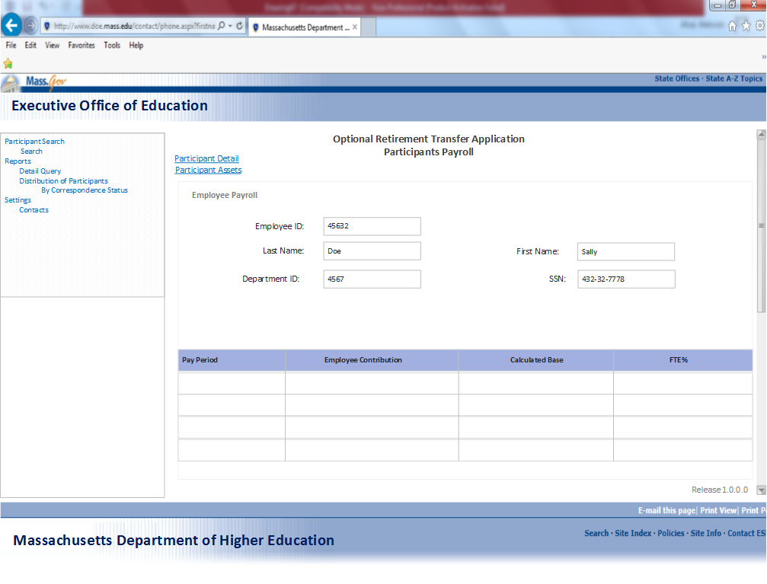

* + 1. **Field Related Information for `Employee Payroll’**

|  |  |  |  |  |  |  |
| --- | --- | --- | --- | --- | --- | --- |
| ***Field Name*** | ***Input / Output*** | ***Field Size*** | ***Mandatory/ Optional*** | ***Valid Character Type(/Special/Alpha Numeric/Numeric)*** | ***Valid Values*** | ***Notes And Format*** |
| Participants Payroll | Page  Heading | 19 | Mandatory | Alpha(A-Z, a-z) | n/a | Bold |
| Employee Payroll | Table  Heading | 17 | Mandatory | Alpha(A-Z, a-z) | n/a | Bold |
| Participant Details | Link | 17 | Mandatory | Alpha(A-Z, a-z) | n/a | * This is a link and shall take the user back to participants detail page. |
| Participant Assets | Link | 17 | Mandatory | Alpha(A-Z, a-z) | n/a | * This is a link and shall take the user back to participants Assets page. |
| Employee ID | label | 9 | Mandatory | Numeric | n/a |  |
|  | Field | 10 | Mandatory | Numeric | n/a | * This shall display the employee ID number. |
| Last Name | label | 9 | Mandatory | Alpha(A-Z, a-z) | n/a |  |
|  | Field | 9 | Mandatory | Alpha(A-Z, a-z) | n/a | * This shall display employees last name. |
| First Name | label | 9 | Mandatory | Alpha(A-Z, a-z) | n/a |  |
|  | Field | 9 | Mandatory | Alpha(A-Z, a-z) | n/a | * This shall display employees First name. |
| Department ID | label | 9 | Mandatory | Numeric | n/a |  |
|  | Field | 9 | Mandatory | Alpha(A-Z, a-z) | n/a | * This shall display employees department ID. |
| SSN | label | 9 | Mandatory | Numeric | n/a |  |
|  | Field | 9 | Mandatory | Numeric | n/a | * Format:XXX-XX-XXXX |
| **Results table** | | | | | | |
| Pay period | label | 9 | Mandatory | Numeric | n/a | * This shall display the dates for employee pay period |
| Employee contribution | label | 9 | Mandatory | Numeric | n/a | * This shall display the percentage of employee contribution. |
| Calculated base | label | 9 | Mandatory | Numeric | n/a | * This shall display the calculated base salary of an employee |
| FTE% | label | 9 | Mandatory | Numeric | n/a | * This shall display the FTE% |

* + 1. **Validation Messages:**

|  |  |  |
| --- | --- | --- |
| **Field** | **Condition** | **Message Displayed**  English Text |
| None |  |  |

* + 1. **Screen Flow**

|  |  |  |
| --- | --- | --- |
| **Button / Menu Option / User Navigation** | **Type** | **Action** |
| Participant Details | Link | Should take the user back to participant details page. |
| Participant Assets | Link | Should take the user back to participant assets page. |

* 1. **Contacts:**
     1. **Functional Requirements:**

1. System shall display a settings page with all the contacts information.
2. User shall be displayed with contact search criteria where they can type in a name and contact type and see the results in the grid displayed below.
3. A contact type could be Campus/Provider and Commonwealth
4. User shall be able to select one or both the search criteria to narrow or broaden the search.
5. System shall display the results grid with contact name, phone, email address and an action field.
6. From the action field user shall be able to update or delete an existing contact.
7. User shall also be able to add a new contact to the system by filling in contact name, phone and email address.

* + 1. **Screen Mock Up:**

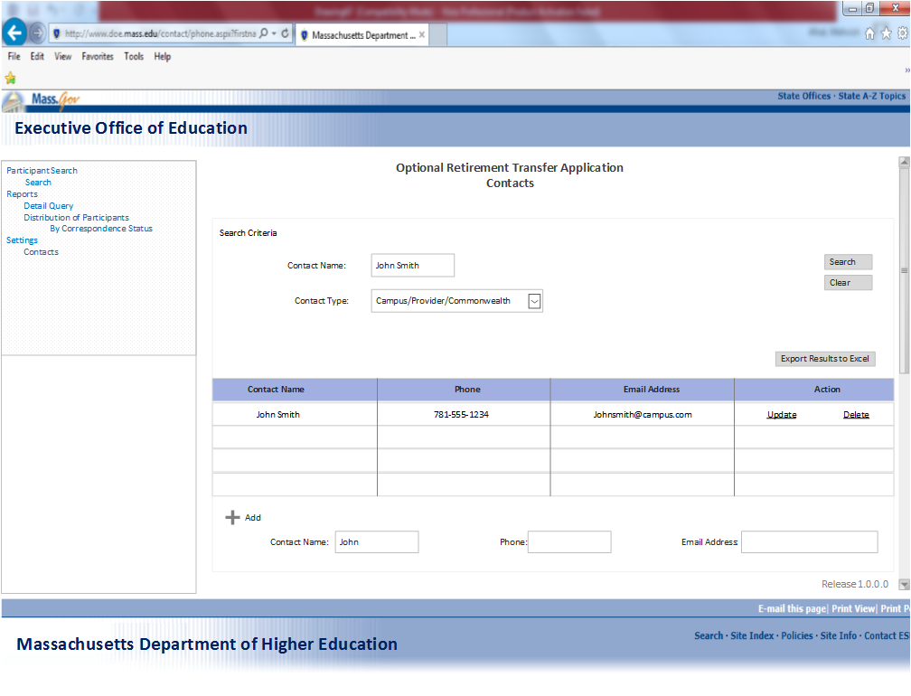

* + 1. **Field Related Information for `Contacts Search Criteria’**

|  |  |  |  |  |  |  |
| --- | --- | --- | --- | --- | --- | --- |
| ***Field Name*** | ***Input / Output*** | ***Field Size*** | ***Mandatory/ Optional*** | ***Valid Character Type(/Special/Alpha Numeric/Numeric)*** | ***Valid Values*** | ***Notes And Format*** |
| Contacts | Page  Heading | 19 | Mandatory | Alpha(A-Z, a-z) | n/a | Bold |
| Search Criteria | Section  Heading | 17 | Mandatory | Alpha(A-Z, a-z) | n/a |  |
| Contact Name | label | 9 | Mandatory | Alpha(A-Z, a-z) | n/a |  |
|  | Field | 9 | Mandatory | Alpha(A-Z, a-z) | n/a | * Format: Last Name, First Name |
| Contact Type | label | 9 | Mandatory | Alpha(A-Z, a-z) | * Campus * Provider * Commonwealth | * System shall display a drop list with three contact categories. |
|  | Field | 9 | Mandatory | Alpha(A-Z, a-z) | * Campus * Provider * Commonwealth | * Drop list shall include Campus/provider and Commonwealth in these Contact categories |
| Search | Label | 9 | Mandatory | Alpha(A-Z, a-z) |  | * Search should query ORTA as required. * Search results must include: Contact Nme, Phone, Email Address and Action field. * All the data entered/selections made in the search criteria fields must be retained in the fields after search is complete, so that user does not have to enter/select them again after search. * If user has not entered/selected some search criteria and default values have been used for that search. After search is complete, search criteria fields should display the default values used for that particular search. * At least one field is required to do a search. |
| Clear | Label | 9 | Mandatory | Alpha(A-Z, a-z) |  | * Clear all the search criteria entered/selected and will set to default values. |
| Export To Excel | Label | 9 | Mandatory | Alpha(A-Z, a-z) |  | * Execute Excel file displaying the contents of the result and search criteria have to be included in the XL File. * If search spans to multiple display pages, data from all the pages has to be included in the XL file. * Data order (rows & Columns) in the XL should be in the current Sort Order. |
| Search Results table | | | | | | |
| Contact Name | Label | 15 | Mandatory | Alpha | n/a | Format: Last Name, First Name |
| Phone | label | 9 | Mandatory | Numeric | n/a |  |
|  | Field | 12 | Mandatory | Numeric | n/a | * Format:XXX-XXX-XXXX |
| Email address | label | 10 | Mandatory | Alpha numeric | n/a |  |
|  | Field | 10 | Mandatory | Alpha numeric | n/a | * Format:Johnsmith@campus.com |
| Action | label | 9 | Mandatory | Alpha(A-Z, a-z) | * Update * Delete |  |
|  | Field | 9 | Mandatory | Alpha(A-Z, a-z) | * Update * Delete | * Update shall be able to update contacts information in the table. * Delete shall delete a participants from the search results. |
| Add | label | 9 | Mandatory | Alpha(A-Z, a-z) | * Contact Name * Phone * Email address | * User shall be able to add a new contact to the system. |
|  | Field | 9 | Mandatory | Alpha(A-Z, a-z) | * Contact Name * Phone * Email address | * User must add the contact name, phone and email address to add a person to the system. |

* + 1. **Validation Messages:**

|  |  |  |
| --- | --- | --- |
| **Field** | **Condition** | **Message Displayed**  English Text |
| Add | User must enter all the fields (Contact name, Phone, and email address) to add a contact. | You must enter all the fields to add a contact |

* + 1. **Screen Flow**

|  |  |  |
| --- | --- | --- |
| **Button / Menu Option / User Navigation** | **Type** | **Action** |
| Search | Pushbutton | Query ORTA with selected search criteria and display results below in grid format. Search results should include Correspondence status and total participants |
| Clear | Pushbutton | Clear all the search criteria entered/selected and will set to default values. |
| Export Results to Excel | Link | This is a link to execute and download Excel file displaying the contents of the search result and search criteria entered/selected. |
| Add | Pushbutton | Adds a contact to the contact list. |

* 1. **Detail Query Report:**
     1. **Functional Requirements:**

1. System shall display a `Detail Query Report’ for admin users.
2. User shall be able to select multiple statuses at a time from the `Correspondence status type’ to see the results in the results grid table below.
3. User shall be able to select a date range and include it in the search criteria as well.
4. User shall be able to select one or both the search parameters to broaden or narrow down the reach results.
5. User must select at least one criterion in order to get results in the results grid.

* + 1. **Screen Mock Up:**

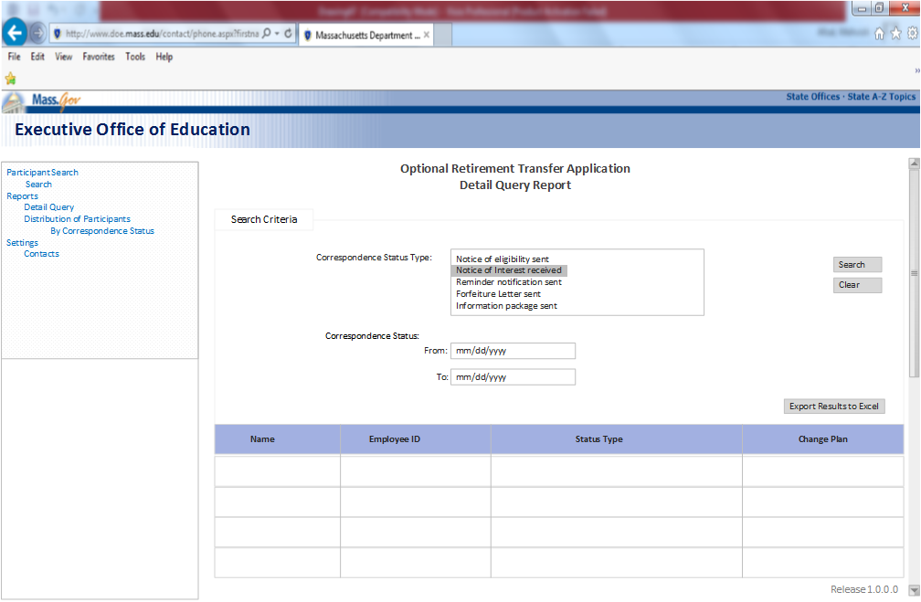

* + 1. **Field Related Information for Detail Query Search Criteria:**

|  |  |  |  |  |  |  |  |
| --- | --- | --- | --- | --- | --- | --- | --- |
| ***Field Name*** | ***Input / Output*** | ***Field Size*** | ***Mandatory/ Optional*** | ***Valid Character Type(/Special/Alpha Numeric/Numeric)*** | ***Valid Values*** | ***Notes And Format*** | |
| Detail Query Report | Page  Heading | 30 | Mandatory | Alpha(A-Z, a-z) | n/a | Bold | |
| Search Criteria | Section  Label | 17 | Mandatory | Alpha(A-Z, a-z) | n/a |  | |
| Correspondence Status Type | Label | 30 | Mandatory | Alpha(A-Z, a-z) | List all the correspondence statuses |  | |
|  | Field | 30 | Mandatory | Alpha(A-Z, a-z) | List all the correspondence statuses | * This is a multi select field. * User shall be able to select multiple correspondence statuses at a time and system shall display the results grid with the selected statuses and the total number of participants in that status. | |
| Correspondence Status | Label | 39 | Mandatory | Alpha(A-Z, a-z) | n/a | * Shall display all the correspondence statuses. | |
| To | Label | 9 | Mandatory | Numeric | n/a | * Date selection papa meter. | |
|  | Field | 10 | Mandatory | Numeric | n/a | * Format: mm/dd/yyyy * User should be able to select the date using a date picker tool. * User will be able to edit day, month, and year or set it to a blank field. | |
| From | Label | 9 | Mandatory | numeric | n/a | * Date selection parameter | |
|  | Field | 10 | Mandatory | numeric | n/a | * Format: mm/dd/yyyy * If “To” date is picked, but no “From” date is picked, system should default to1/1/<current year> for from date. * User should be able to select the date using a date picker tool. * User will be able to edit day, month, and year or set it to a blank field. | |
| Search | Label | 9 | Mandatory | Alpha(A-Z, a-z) |  | * Search should query ORTA as required. * Search results must include: Correspondence status and total participants. * All the data entered/selections made in the search criteria fields must be retained in the fields after search is complete, so that user does not have to enter/select them again after search. * If user has not entered/selected some search criteria and default values have been used for that search. After search is complete, search criteria fields should display the default values used for that particular search. * At least one field is required to do a search. | |
| Clear | Label | 9 | Mandatory | Alpha(A-Z, a-z) |  | * Clear all the search criteria entered/selected and will set to default values. | |
| Export To Excel | Label | 9 | Mandatory | Alpha(A-Z, a-z) |  | * Execute Excel file displaying the contents of the result and search criteria have to be included in the XL File. * If search spans to multiple display pages, data from all the pages has to be included in the XL file. * Data order (rows & Columns) in the XL should be in the current Sort Order. | |
| **Search Results Table** | | | | | | | |
| Name | Label | 9 | Mandatory | Alpha(A-Z, a-z) | n/a | | * Format: Last, First Middle Initial of the participant. |
| Employee ID | Label | 9 | Mandatory | Alpha(A-Z, a-z) | n/a | | * Displays an employee ID |
| Status Type | Label | 9 | Mandatory | Alpha(A-Z, a-z) | n/a | | * Displays participants status in the process |
| Change plan | Label | 9 | Mandatory | Alpha(A-Z, a-z) | n/a | | * Displays participants plan or Yes or no |

* + 1. **Validation Messages:**

|  |  |  |
| --- | --- | --- |
| **Field** | **Condition** | **Message Displayed**  English Text |
| Correspondence Status: | User must select one option from the correspondence status dropdown to see the report | You must select one option from the drop down to view the report. |
| Search | Pushbutton | User needs to select on criteria from the dropdown and push search button to initiate the search. |
| To and From | If any of the Date fields listed is not in format MM/DD/YYYY | Please enter XXXXXXX in MM/DD/YYYY format. |

* + 1. **Screen Flow**

|  |  |  |
| --- | --- | --- |
| **Button / Menu Option / User Navigation** | **Type** | **Action** |
| Search | Pushbutton | Query ORTA with selected search criteria and display results below in grid format. Search results should include Correspondence status and total participants |
| Clear | Pushbutton | Clear all the search criteria entered/selected and will set to default values. |
| Export Results to Excel | Link | This is a link to execute and download Excel file displaying the contents of the search result and search criteria entered/selected. |

* 1. **Distribution by correspondence status report:**
     1. **Functional Requirements:**

1. System shall display a `Distribution of correspondence status report’ for admin users.
2. System shall display a search criteria where users can select multiple correspondence statuses to see how many total participants are there in a status.
3. User shall be able to select a date range to narrow or broaden their search.
4. System shall display results grid table on the bottom of the page to show results based on the search criteria.
5. Research results will be show in what format? Which one will come first?
6. User needs to select at least one criterion from correspondence status or to and from date fields to get the search results.

* + 1. **Screen Mock Up:**

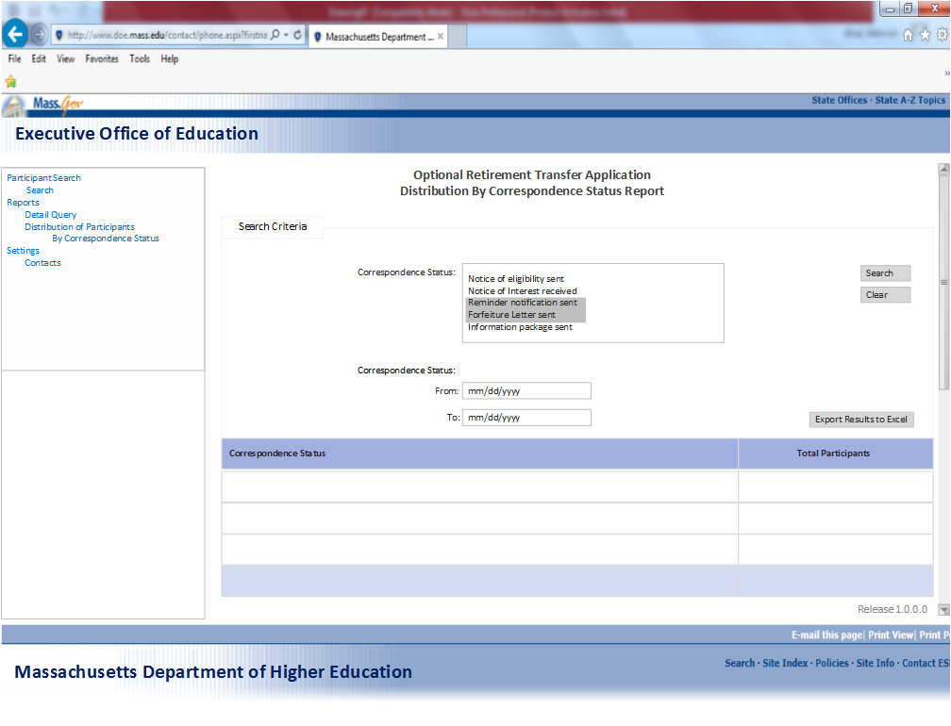

* + 1. **Field Related Information for `Correspondence Status Search Criteria’**

|  |  |  |  |  |  |  |
| --- | --- | --- | --- | --- | --- | --- |
| ***Field Name*** | ***Input / Output*** | ***Field Size*** | ***Mandatory/ Optional*** | ***Valid Character Type(/Special/Alpha Numeric/Numeric)*** | ***Valid Values*** | ***Notes And Format*** |
| Distribution by correspondence status report | Page  Heading | 30 | Mandatory | Alpha(A-Z, a-z) | n/a | Bold |
| Search Criteria | Section  Heading | 17 | Mandatory | Alpha(A-Z, a-z) | n/a |  |
| Correspondence Status | Label | 30 | Mandatory | Alpha(A-Z, a-z) | List of all the correspondence statuses | * Shall display all the correspondence statuses. |
|  | Field | 57 | Mandatory | Alpha(A-Z, a-z) | List of all the correspondence statuses | * This is a multi select field. * User shall be able to select multiple correspondence statuses at a time and system shall display the results grid with the selected statuses and the total number of participants in that status. |
| To | Label | 9 | Mandatory | Numeric |  | * Date selection Para meter. |
|  | Field | 9 | Mandatory | Numeric |  | * Format: mm/dd/yyyy * User should be able to select the date using a date picker tool. * User will be able to edit day, month, and year or set it to a blank field. |
| From | Label | 9 | Mandatory | numeric |  | * Date selection parameter |
|  | Field | 9 | Mandatory | numeric |  | * Format: mm/dd/yyyy * If “To” date is picked, but no “From” date is picked, system should default to1/1/<current year> for from date. * User should be able to select the date using a date picker tool. * User will be able to edit day, month, and year or set it to a blank field. |
| Search | Pushbutton | 9 | Mandatory | Alpha(A-Z, a-z) |  | * Search should query ORTA as required. * Search results must include: Correspondence status and total participants information. * All the data entered/selections made in the search criteria fields must be retained in the fields after search is complete, so that user does not have to enter/select them again after search. * If user has not entered/selected some search criteria and default values have been used for that search. After search is complete, search criteria fields should display the default values used for that particular search. * At least one field is required to do a search. |
| Clear | Pushbutton | 9 | Mandatory | Alpha(A-Z, a-z) |  | * Clear all the search criteria entered/selected and will set to default values. |
| Export to Excel | Pushbutton | 9 | Mandatory | Alpha(A-Z, a-z) |  | * Execute Excel file displaying the contents of the result and search criteria have to be included in the XL File. * If search spans to multiple display pages, data from all the pages has to be included in the XL file. * Data order (rows & Columns) in the XL should be in the current Sort Order. |
| **Search Results Table** | | | | | | |
| Correspondence Status | Table Label | 17 | Mandatory | Alpha(A-Z, a-z) | n/a | * Shall display correspondence statuses based on the criteria selected in the search. |
| Total Participants | Table Label | 9 | Mandatory | Alpha(A-Z, a-z) |  | * Shall display total number of participants in the correspondence statuses |

* + 1. **Validation Messages:**

|  |  |  |
| --- | --- | --- |
| **Field** | **Condition** | **Message Displayed**  English Text |
| Correspondence Status: | User must select one option from the correspondence status dropdown to see the report | You must select one option from the drop down to view the report. |
| Search | Pushbutton | User needs to select on criteria from the dropdown and push search button to initiate the search. |
| To and From | If any of the Date fields listed is not in format MM/DD/YYYY | Please enter XXXXXXX in MM/DD/YYYY format. |

* + 1. **Screen Flow**

|  |  |  |
| --- | --- | --- |
| **Button / Menu Option / User Navigation** | **Type** | **Action** |
| Search | Push  Button | Query ORTA with selected search criteria and display results below in grid format. Search results should include Correspondence status and total participants |
| Clear | Push  Button | Clear all the search criteria entered/selected and will set to default values. |
| Export Results to Excel | Push  Button | This is a link to execute and download Excel file displaying the contents of the search result and search criteria entered/selected. |

* 1. **Distribution of Participants report:**
     1. **Functional Requirements:**

1. System shall display distribution of participants by correspondence report for admin.
2. System shall display `Distribution of participants’ labels with a dropdown to select the options from.
3. A `Distribution of Participants by correspondence Status’ link shall be displayed on the screen for the user to quickly launch the report.
4. User shall be able to retrieve the same report from the left side navigation, by clicking on the `by correspondence status’ link.

* + 1. **Screen Mock Up:**

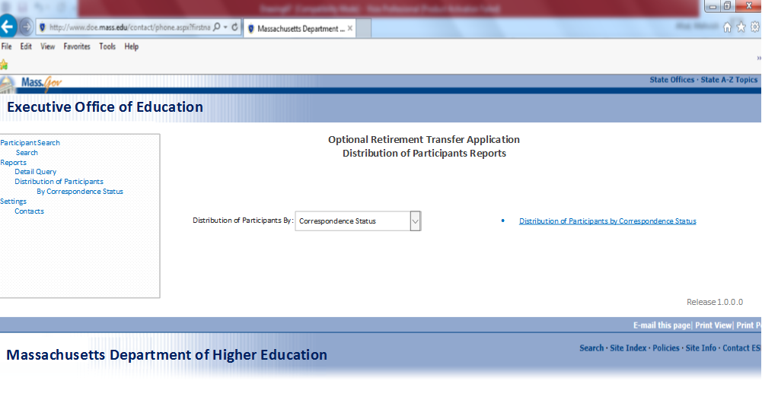

* + 1. **Field Related Information for `Participants Report Search Criteria’**

|  |  |  |  |  |  |  |
| --- | --- | --- | --- | --- | --- | --- |
| ***Field Name*** | ***Input / Output*** | ***Field Size*** | ***Mandatory/ Optional*** | ***Valid Character Type(/Special/Alpha Numeric/Numeric)*** | ***Valid Values*** | ***Notes And Format*** |
| Distribution of participants Report | Page  Heading | 30 | Mandatory | Alpha(A-Z, a-z) | n/a | Bold |
| Distribution of participants by | Label | 30 | Mandatory | Alpha(A-Z, a-z) | Correspondence Status |  |
|  | Field | 30 | Mandatory | Alpha(A-Z, a-z) | Correspondence Status | User shall be able to generate a report based on the correspondence statuses of participants. |
| Distribution of participants by correspondence status | Link | 30 | Mandatory | Alpha(A-Z, a-z) |  | This is a link for the same report. User shall be able to click this link to generate `Distribution of participants by correspondence status report. |

* + 1. **Validation Messages:**

|  |  |  |
| --- | --- | --- |
| **Field** | **Condition** | **Message Displayed**  English Text |
| Distribution of Participant by: | User must select one option from the dropdown to see the report | You must select one option from the drop down to view the report. |

* + 1. **Screen Flow**

|  |  |  |
| --- | --- | --- |
| **Button / Menu Option / User Navigation** | **Type** | **Action** |
| Distribution of Participants by correspondence status | link | Click to launch the report |

* 1. **Distribution of Reminder/Forfeiture report:**
     1. **Functional Requirements:**

1. System shall display Reminder/forfeiture report link on the left navigation.
2. Clicking on the link shall take the user to Reminder/forfeiture repost page.
3. User shall be able to run this report and get all the candidates to whom the Notice of eligibility or forfeiture letters is to be sent.
4. All the participants shall be selected by default.
5. User shall be able to select and deselect participants through the check boxes displayed on the left.
   * 1. **Screen Mock Up:**

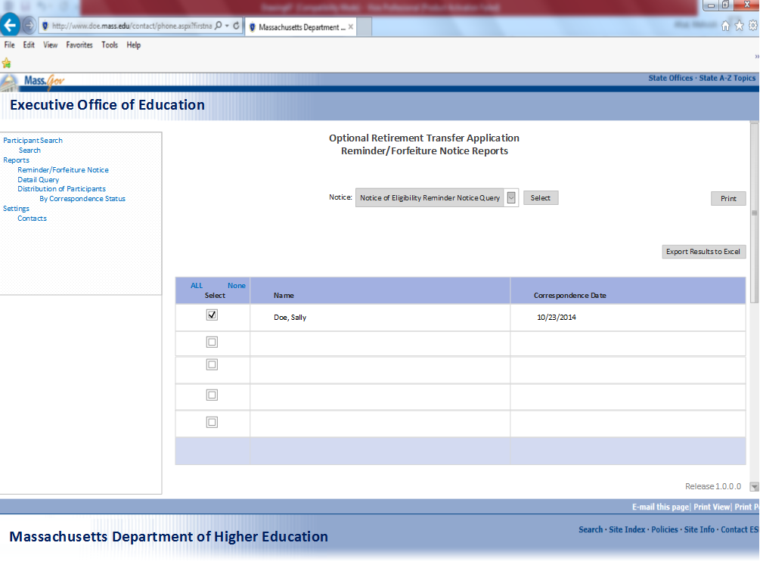

* + 1. **Field Related Information for `Participants Report Search Criteria’**

|  |  |  |  |  |  |  |
| --- | --- | --- | --- | --- | --- | --- |
| ***Field Name*** | ***Input / Output*** | ***Field Size*** | ***Mandatory/ Optional*** | ***Valid Character Type(/Special/Alpha Numeric/Numeric)*** | ***Valid Values*** | ***Notes And Format*** |
| Reminder/  Forfeiture Notice Report | Page  Heading | 19 | Mandatory | Alpha(A-Z, a-z) | n/a | Bold |
| Notice | Label | 17 | Mandatory | Alpha(A-Z, a-z) | -Notice of eligibility reminder notice  -Notice of Eligibility forfeiture Letter  -Information package reminder notice  -Information package forfeiture letter | Bold |
|  | Field | 17 | Mandatory | Alpha(A-Z, a-z) | -Notice of eligibility reminder notice  -Notice of Eligibility forfeiture Letter  -Information package reminder notice  -Information package forfeiture letter | * This is a drop down with four options. * User will be able to select on option at a time and based on the option selected from the drop down the grid table below will populate. |
| Select | Pushbutton | 9 | Mandatory | Alpha(A-Z, a-z) | n/a | * Pushbutton * User will choose an option from the dropdown and push select to see the results in the grid table below. |
| **Results Table** | | | | | | |
| Select | Label | 9 | Mandatory | Alpha(A-Z, a-z) | All/None | * All the search result will be selected by default. * User shall be able to select and deselect participants from the table. * `All’ will select all the participants in the search results. * None will deselect all the participants from the selected fields. |
| Name | Label | 9 | Mandatory | Alpha(A-Z, a-z) | n/a | This should display in the order of last name, first name. |
|  | Field | 9 | Mandatory | Alpha(A-Z, a-z) | n/a |  |
| Correspondence date | Label | 20 | Mandatory | Alpha(A-Z, a-z) | n/a | This shall display the date for the selected notice on the top. |
|  | Field | 10 | Mandatory | Alpha(A-Z, a-z) | n/a | Format: mm/dd/yyyy |
| Print | Pushbutton | 9 | Mandatory | Alpha(A-Z, a-z) | n/a | This button shall print the results in the grid table below. |
| Export to Excel | Pushbutton | 15 | Mandatory | Alpha(A-Z, a-z) | n/a | This is a link to execute and download Excel file displaying the contents of the search result and search criteria entered/selected. |

* + 1. **Validation Messages:**

|  |  |  |
| --- | --- | --- |
| **Field** | **Condition** | **Message Displayed**  English Text |
| Select | User must select one option from the dropdown to see results in the grid below | You must select one option from the drop down to view the report. |

* + 1. **Screen Flow**

|  |  |  |
| --- | --- | --- |
| **Button / Menu Option / User Navigation** | **Type** | **Action** |
| Select | Push  Button | User will choose an option from the dropdown and push select to see the results in the grid table below. |
| All | Push  Button | All will select all the names in the results grid. It will be a default setting. |
| None | Push  Button | None will remove all the selection in the results grid. |
| Print | Push  Button | Print button will print the results in the grid table below. |
| Export to Excel | Push  Button | This is a link to execute and download Excel file displaying the contents of the search result and search criteria entered/selected. |

1. **Appendix**
   1. **Glossary**

|  |  |
| --- | --- |
| **Term** | **Definition** |
| ORP | Optional Retirement Plan |
| SERS | State Employee Retirement System |
| HRCMS | Human Resource Compensation System |
|  |  |
|  |  |
|  |  |
|  |  |

* 1. **References**

|  |  |
| --- | --- |
| **Reference requirements** | **Related reference** |
| Accessibility Requirements | <http://www.mass.gov/portal/massgov-web-accessibility-statement.html> |
| Usability Requirements | <http://usability.gov/guidelines/> |
| Record Retention Requirements | <http://www.sec.state.ma.us/arc/arcpdf/0111.pdf> |

* 1. **Other**

N/A